**Minimize Computation Cost using PSO in Cloud Computing**

**Introduction:**

Particle Swarm Optimization (PSO) was proposed by James Kennedy and Russell Eberhart in 1995. It is the most popular global optimization technique. PSO and Evolutionary technique such as Genetic Algorithm share some similarities. Both the techniques are initialized with a population of random solutions and searches for optimal solution by updating the global functions based on the local fitness function.

In PSO algorithm the particles pbest is calculated using the local fitness function using the parameters of the particle. The global fitness function is to calculate the optimum solution gbest based on the pbest of the particles. These steps are run until the solution converges or run until the user specified number of iterations.

In recent times most of the experiments, which needs large data and high end computing, is performed in distributed environment mainly on cloud due to high performance and low cost provided by the cloud computing. Cloud computing is the emerging technology used by many companies for computing tasks if large data.

**Problem Statement:**

As stated above cloud computing is used mainly for high-end computing and large data with low cost. To provide minimal cost the scheduling of tasks play a vital role in cloud environment. Scheduling helps to map the task to the resources available. Suppose there are N tasks and P resources it becomes a NP optimization problem. The scheduling of the tasks with minimal computational cost is the problem. To minimize the computation cost of tasks in Cloud computing we will use Particle Swarm Optimization technique.

**Overview:**

In cloud computing a large group of remote servers are connected to each other to work as a single large centralized storage system, which allows online access to computer services and resources. In this project we will see how the particle swarm optimization technique can be implemented in cloud computing. We will create a algorithm to schedule the job on the cloud so that the average waiting time is minimal. Many other algorithms along with PSO can be used for this problem. In this we will work on PSO and pso will work greatly on parallel computing problem based on some studies. At the end we will be able to see the particles will be converging towards global minimum waiting time.

**Proposed Solution:**

* + Calculate the average computation cost for each task.
  + Calculate the fitness function value for the solution to find the pbest.
  + Select the solution with best fitness value (pbest) as gbest.
  + Update the fitness value by randomly varying the computation cost
  + Also update the gbest based on the new pbest values.
  + Repeat the steps until the optimal solution is found.

Particle Swarm Algorithm is based on the swarm intelligence technique.

Implemented particle swarm optimization technique for cloud computing to minimize the cost by reducing the average waiting time for task scheduling.

I solve the problem using 2 different methodologies.

In the first method the fitness function is completely based on randomization.

In the second method I modified the algorithm by adding velocity and position constraints and also the fitness function is based on the rank of the position vector of the particle

First the swarm is initialized. In this step we assign random value to position and velocity of the particle.

The next step is to evaluate the fitness value using the fitness function for all the particles in the swarm i.e; pbest. Once we have the pbest for all the particles calculate the global best value gbest.

Store the pbest and gbest values. In the next iteration update the position and velocity of the particles to move towards global best found so far.

The new velocity is calculated as

V' = v + C1 * rand() * (pbest - x) +

               C2 * rand() * (gbest - x);

X' = x + V';

V' - new velocity

X' - new position

C1 - constant 1

C2 - constant 2

Pbest – particle best

gbest – global best

rand - random value generated

x, v - current position and velocity respectively

Once we have the new position and velocity calculate the fitness value again to find the pbest and gbest. Update the pbest if you find the fitness value less than the pbest. Also update the gbest if pbest of any particle is less than gbest.

Repeat the steps until you converge to the global minimum and find the best possible solution or terminate after running for n number of iterations.

The stopping criteria can be number of iterations or of the global minimum is not changing after k number of iterations.

 By adding the velocity and position constraints you can limit the exploration of the particle in the hyper space. Otherwise it might lead to exploitation by exploring random space.

Also choosing the velocity increment very important factor because if the velocity that is incrementing is too big then the particle might miss the best position due to the large veloicty. At the same time if the velocity is too low then the particle will move very little which will take lot of time to converge to the global minimum.

Position.java:

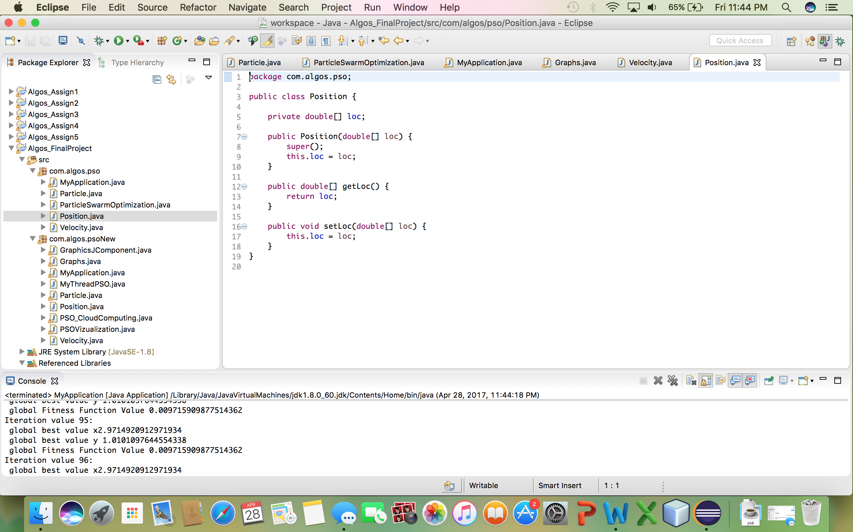

Velocity.java

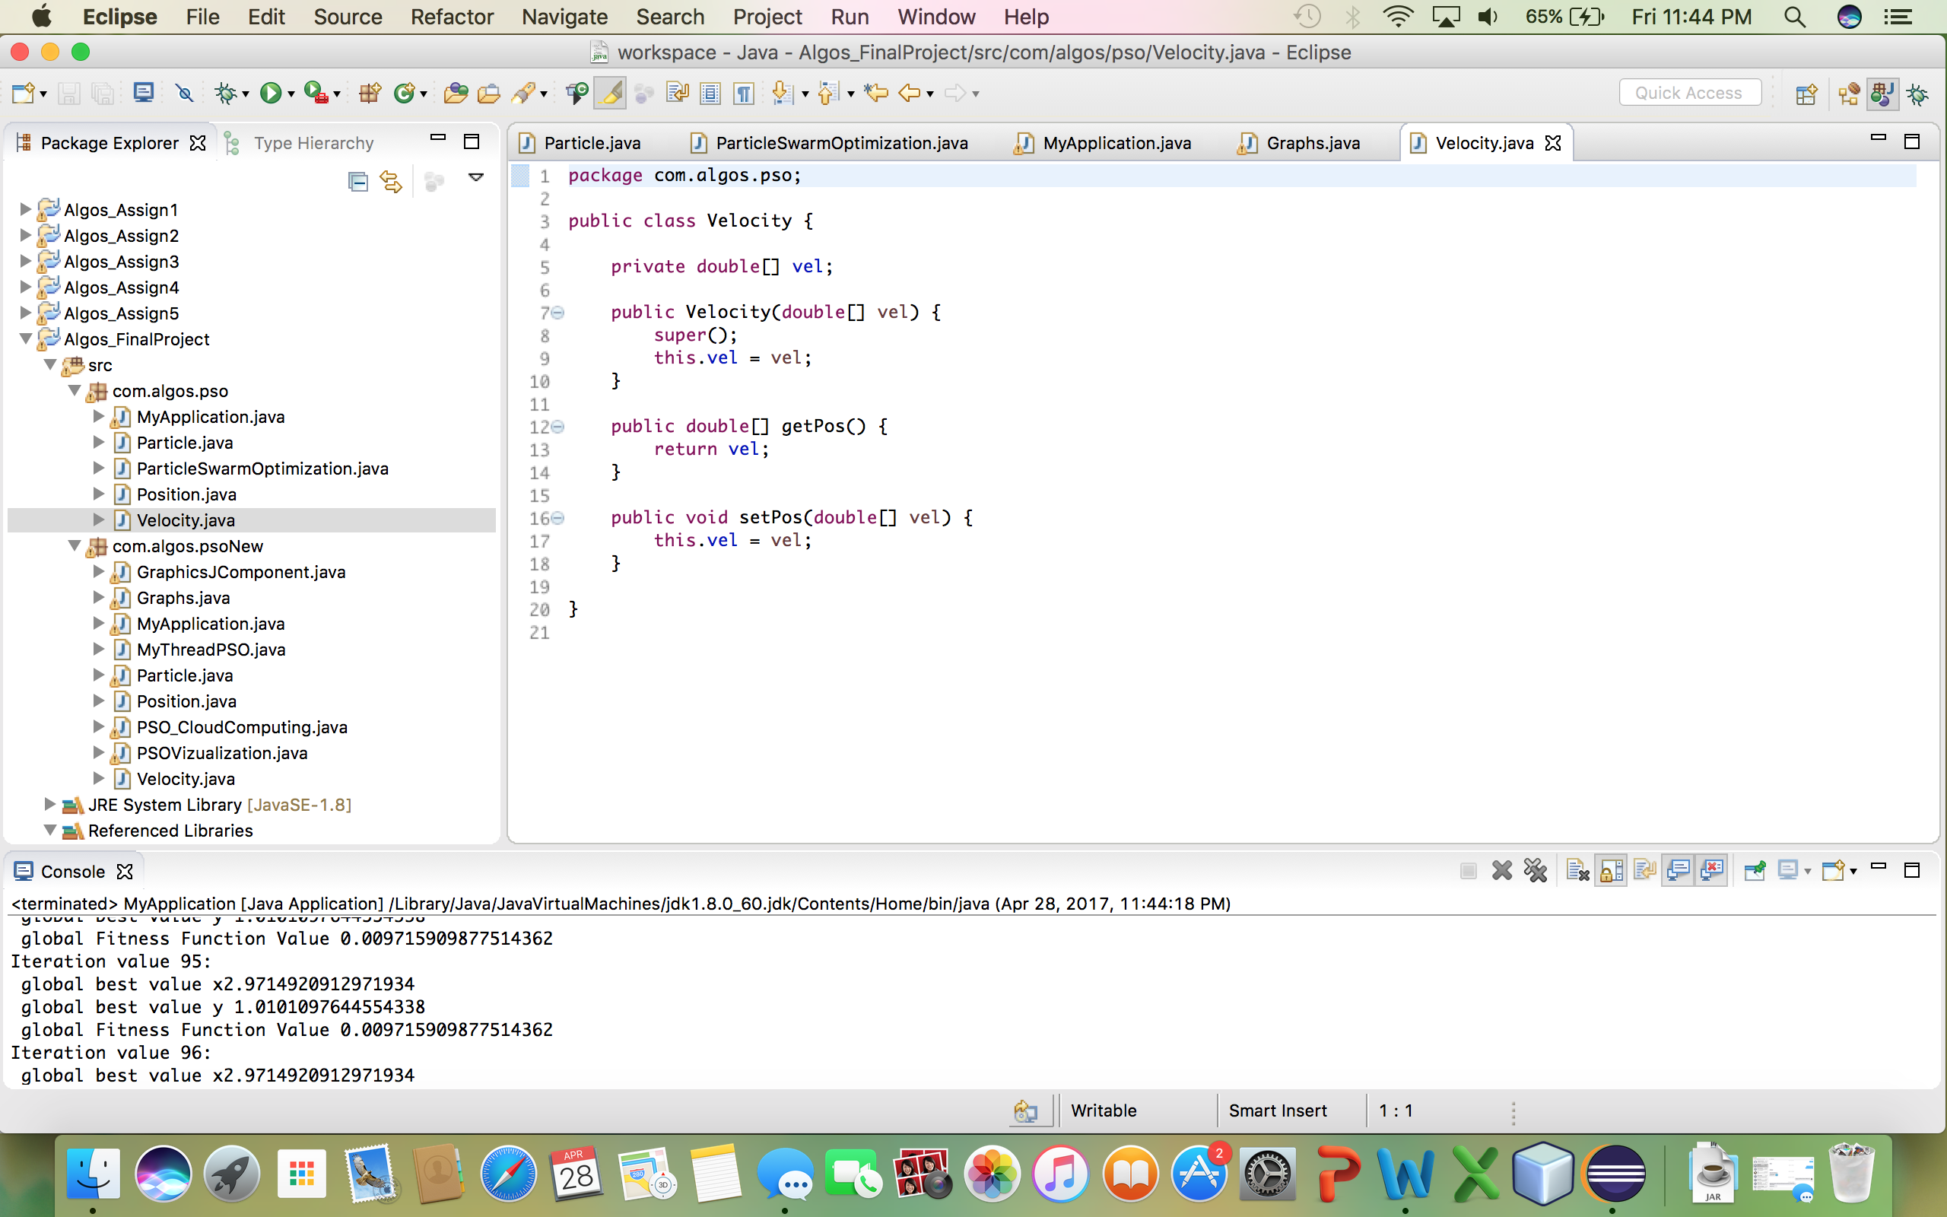

ParticleSwarmOptimization.java

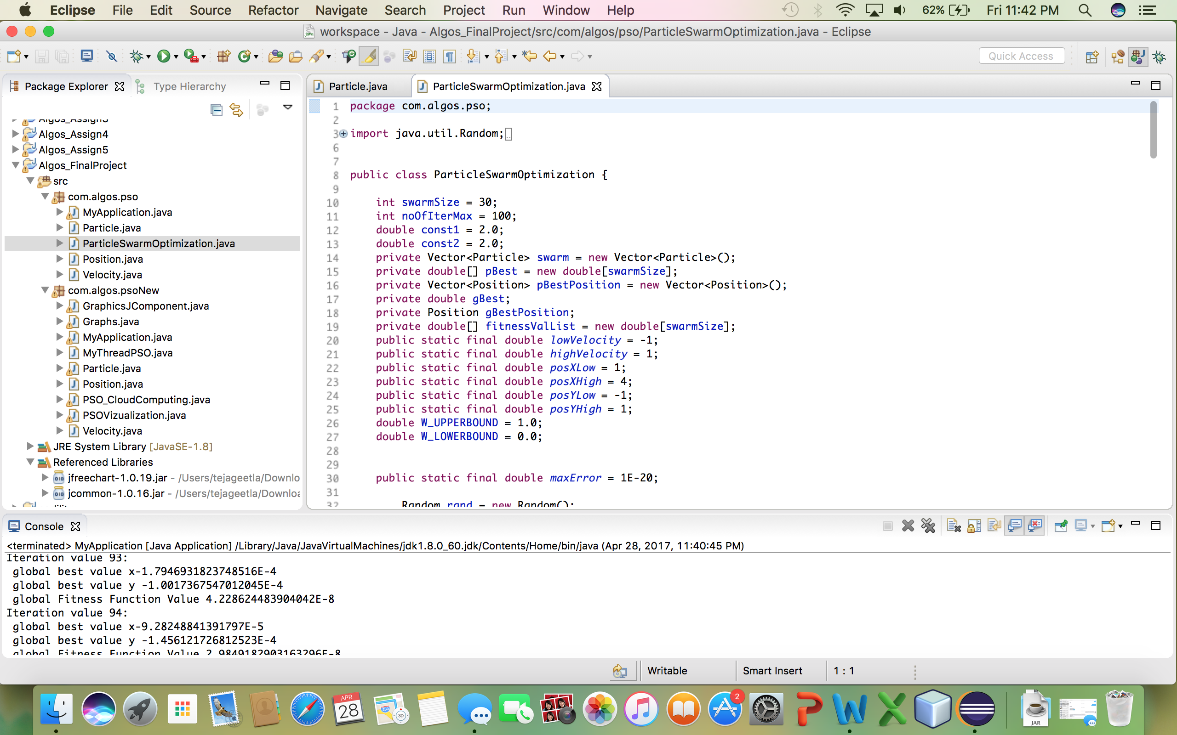

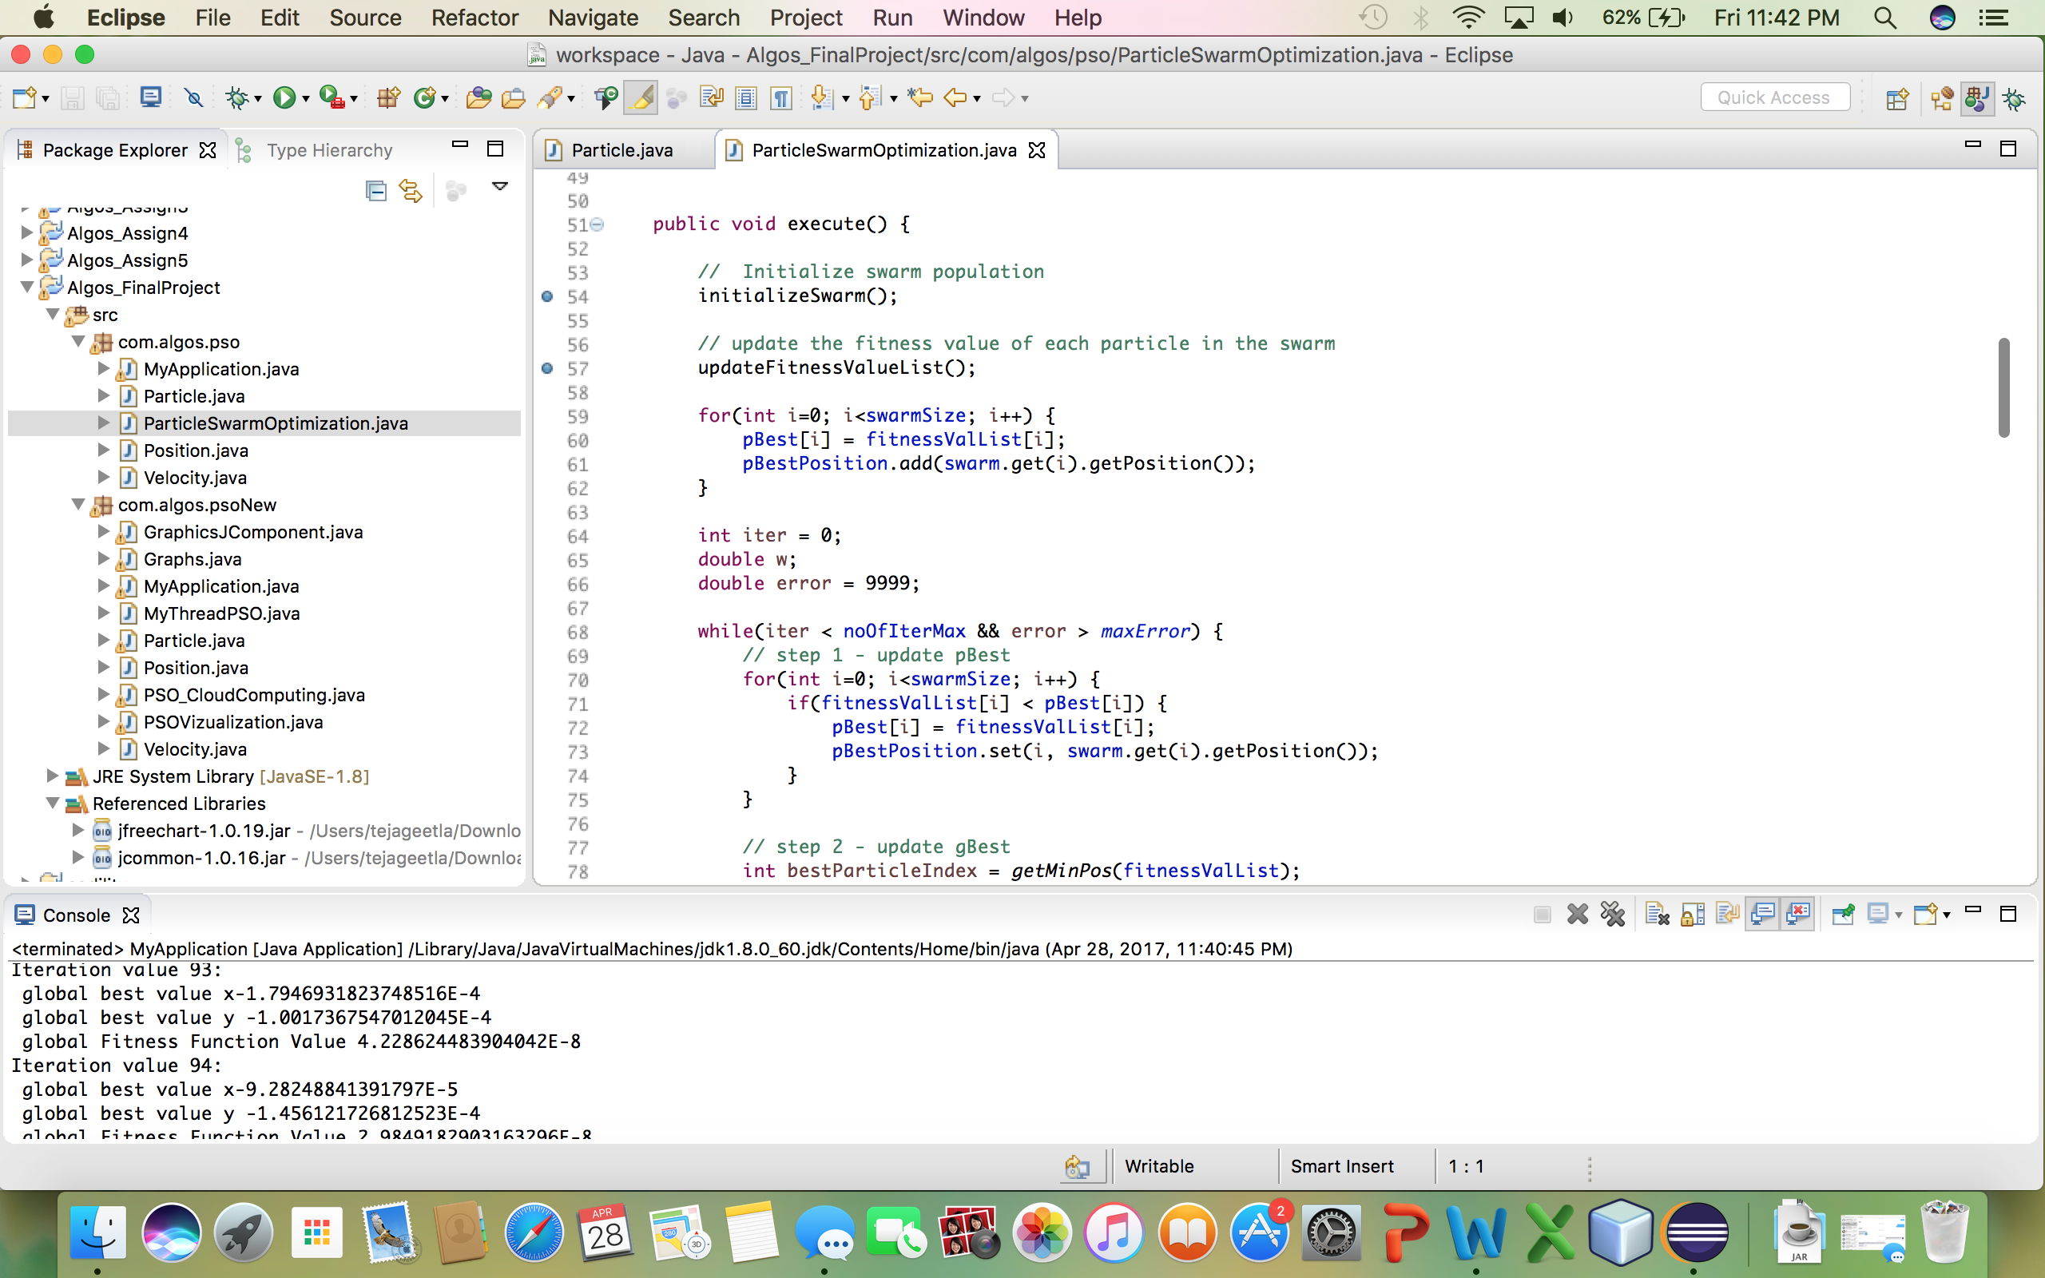

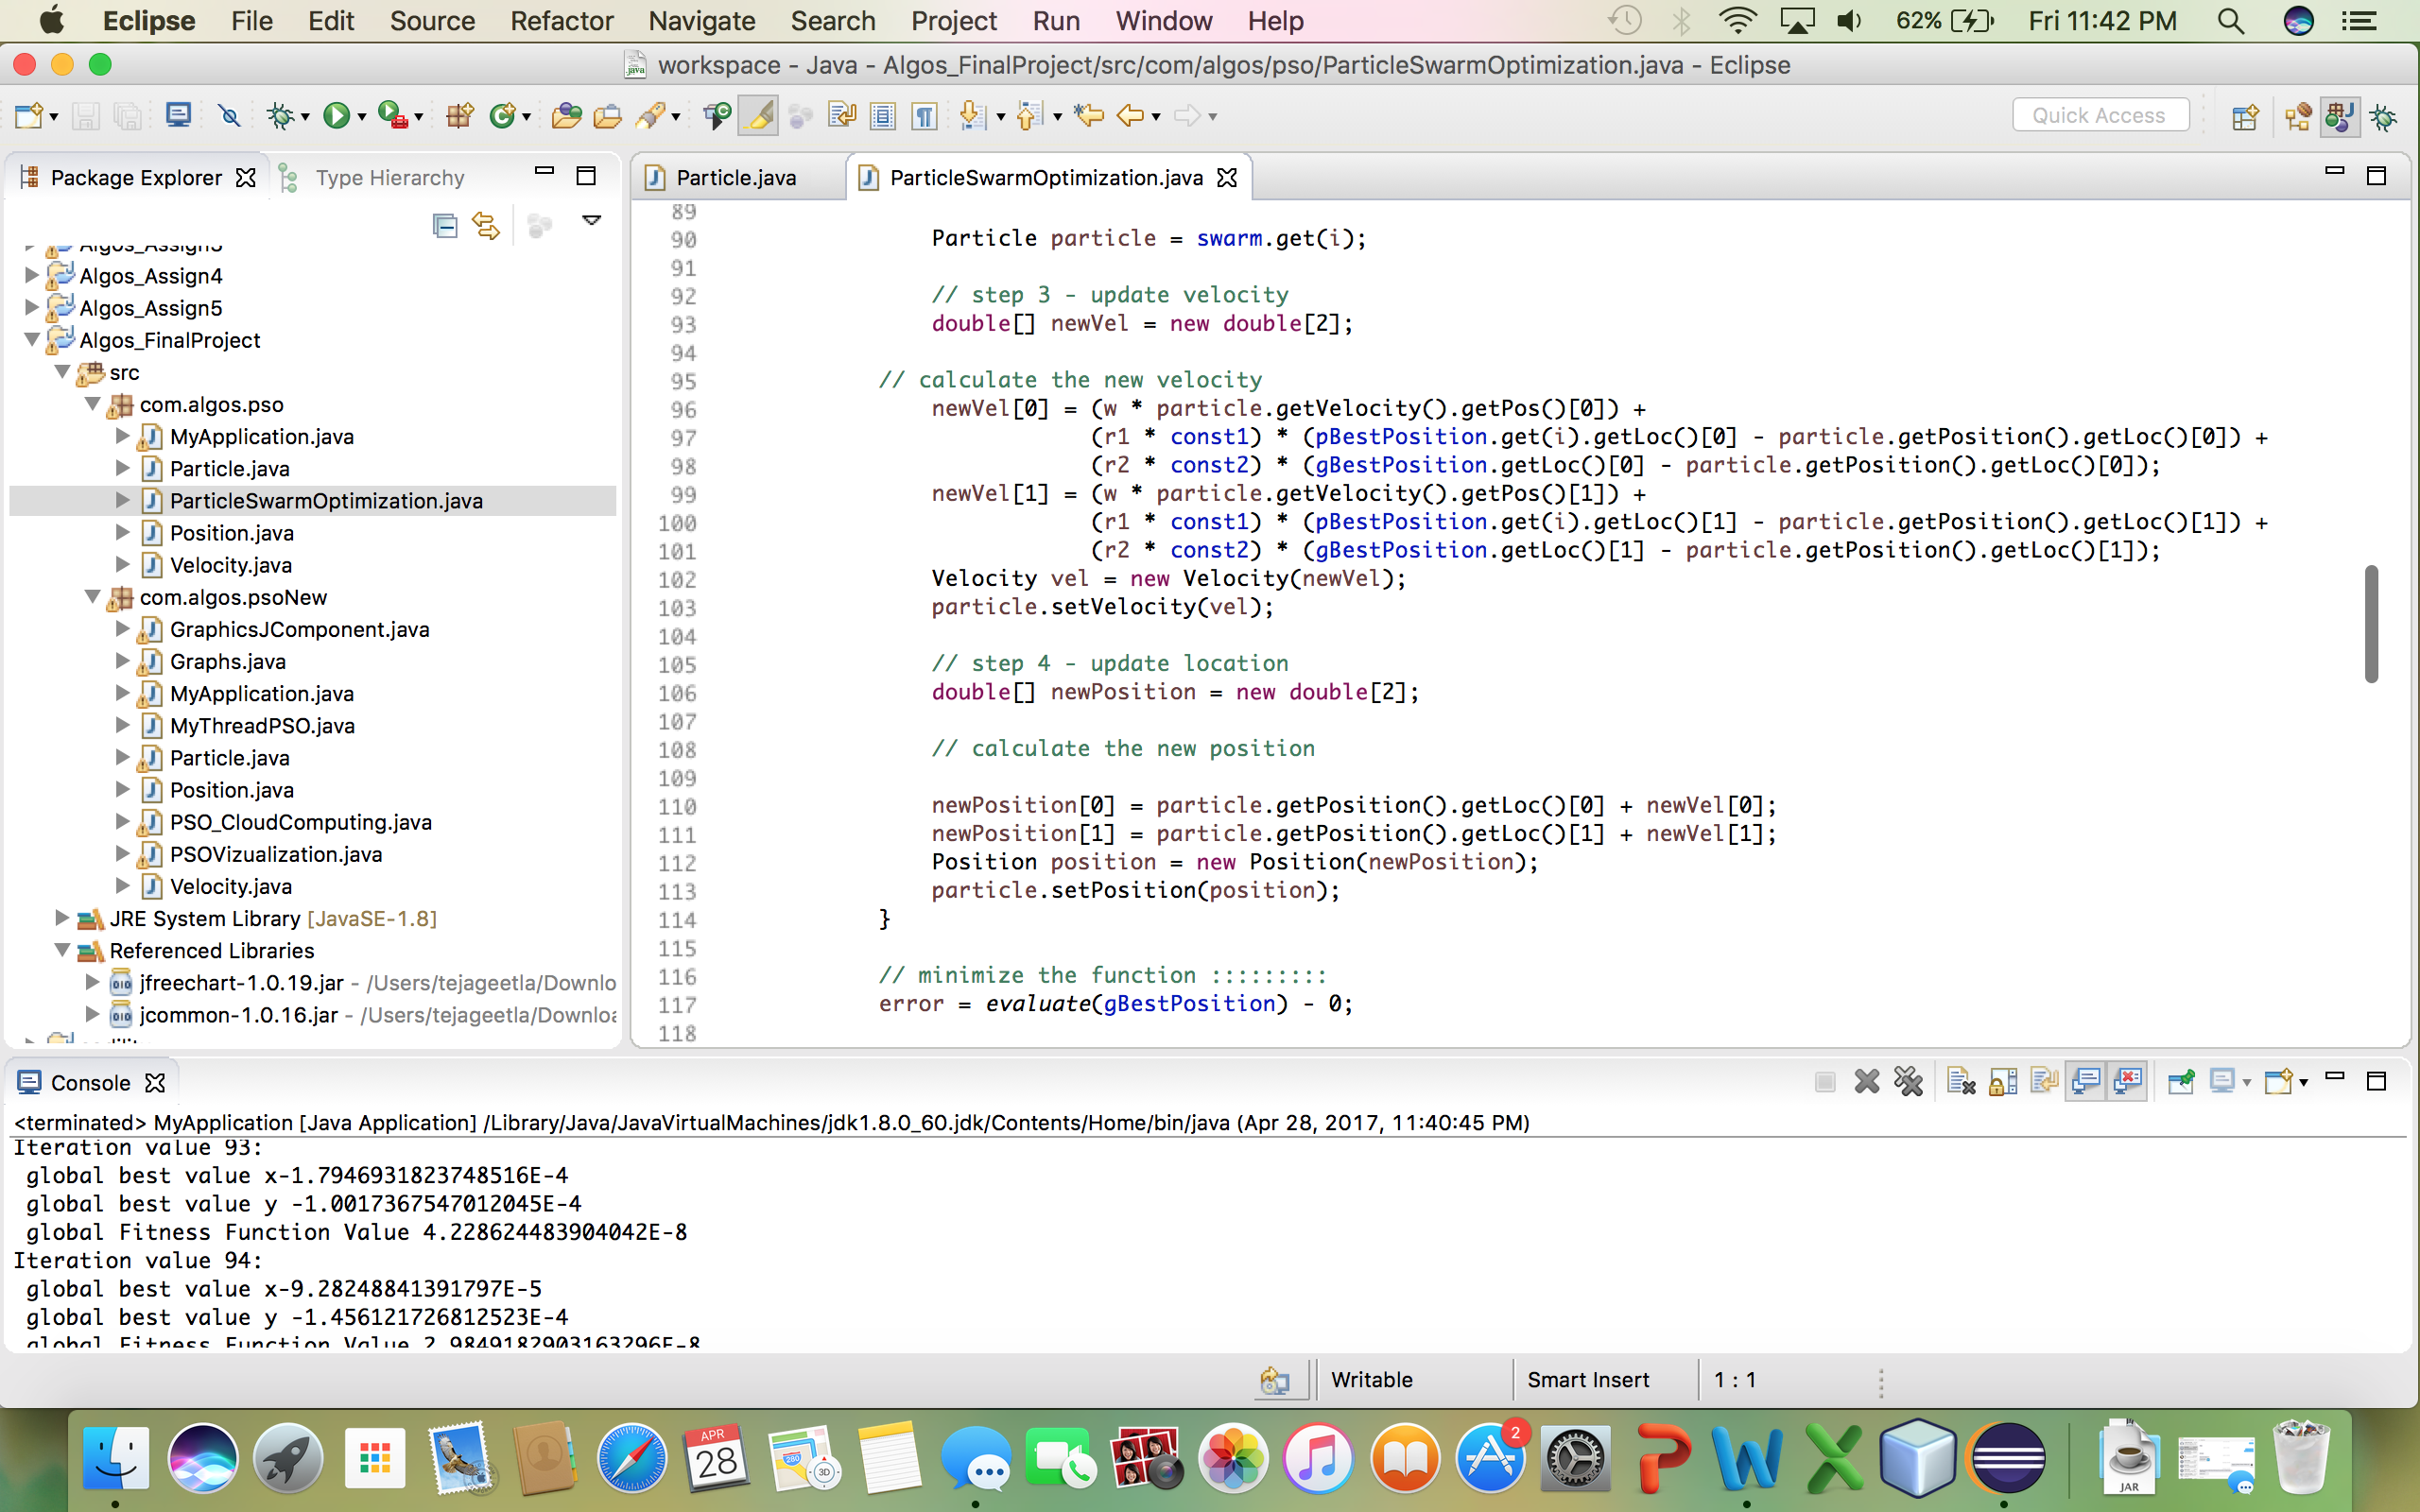

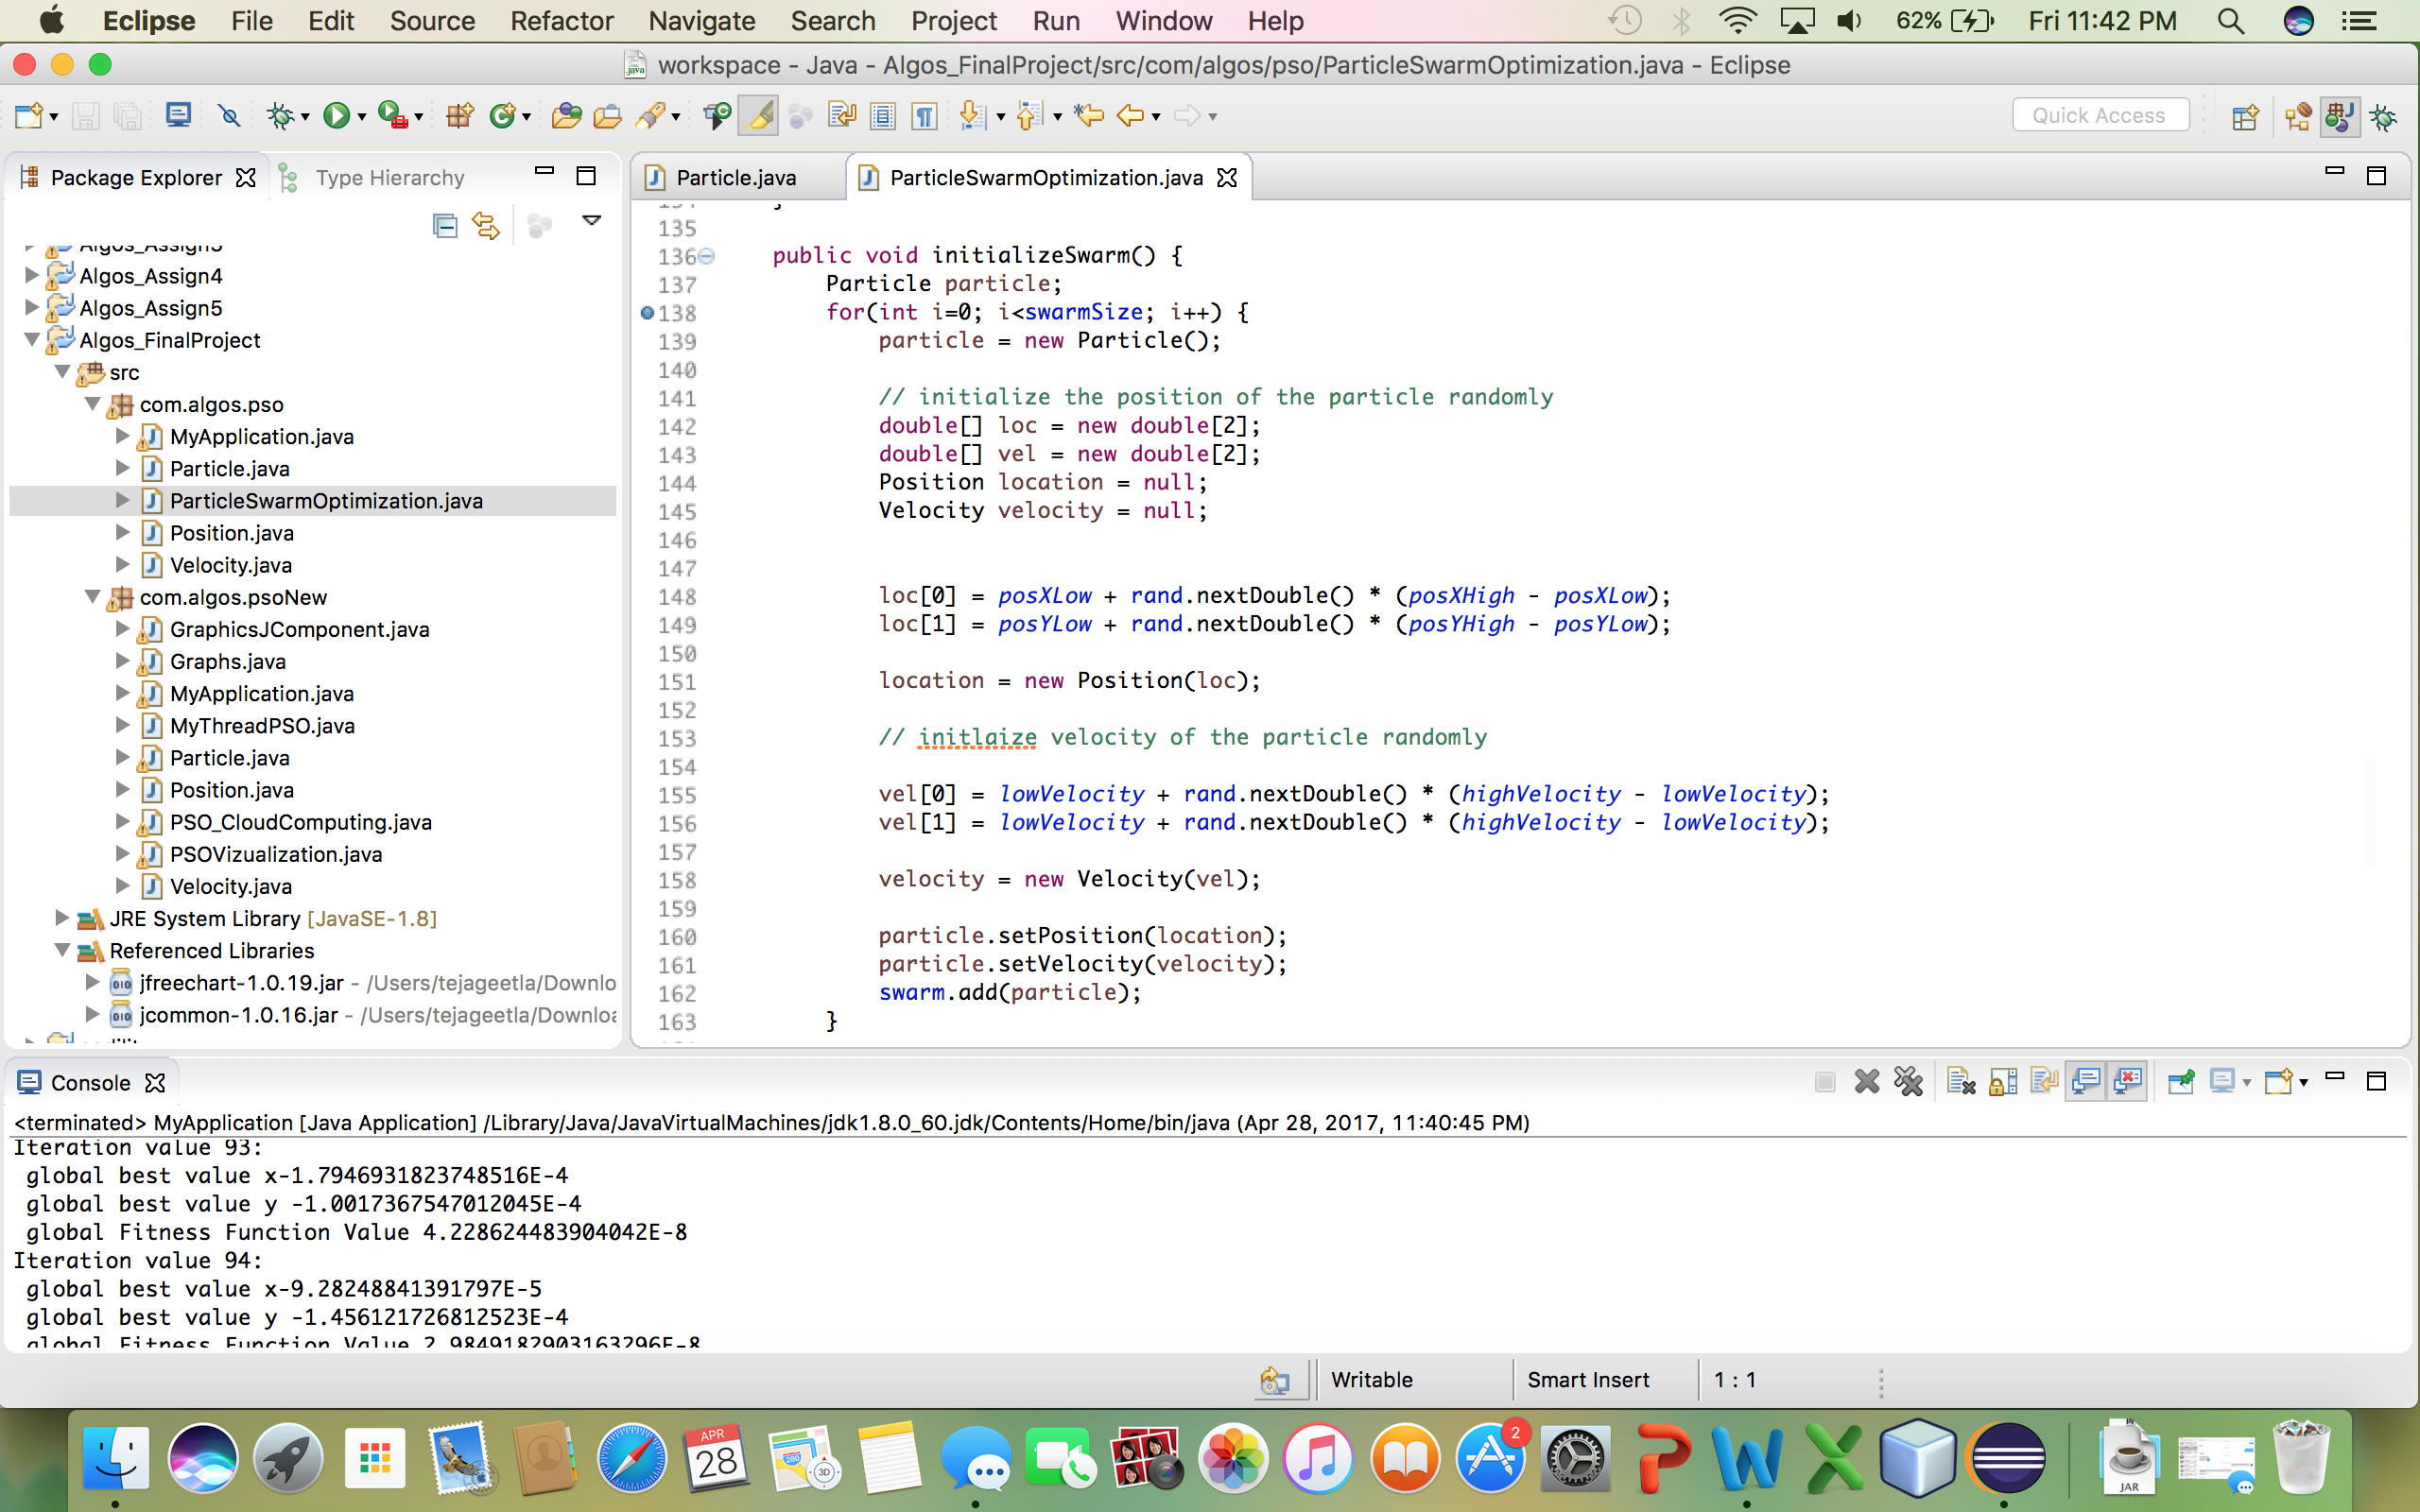

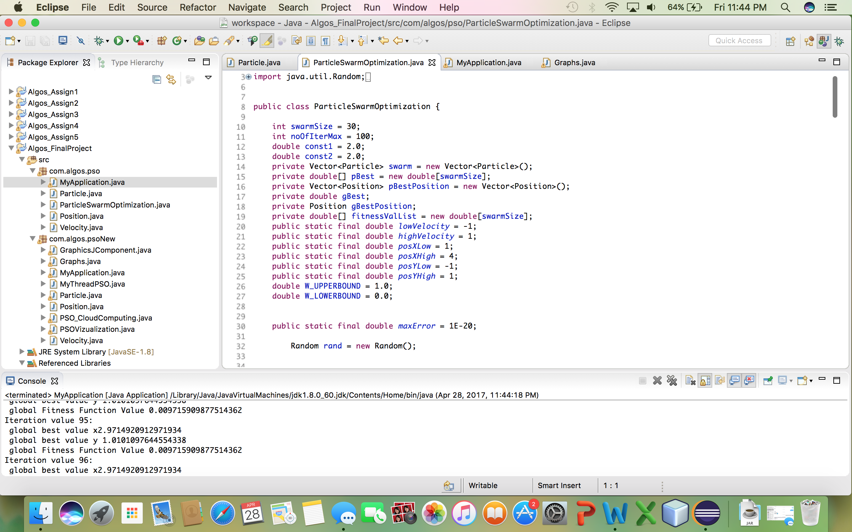

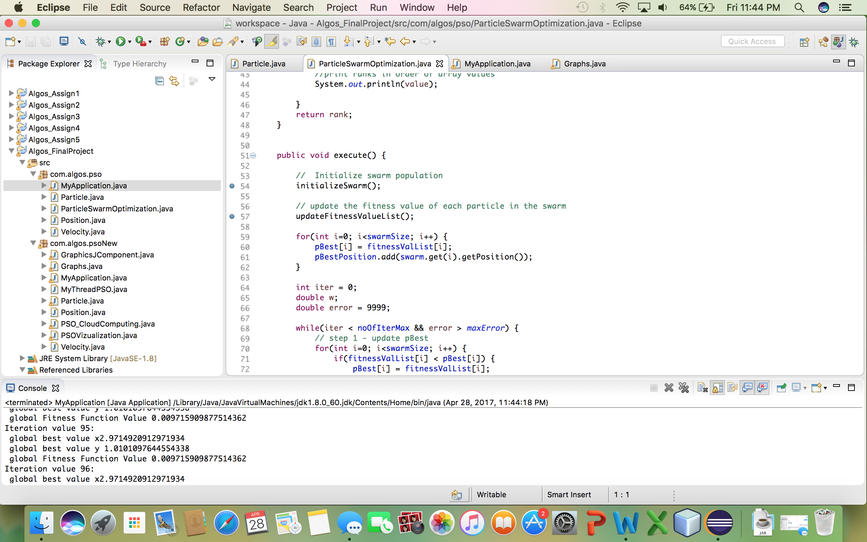

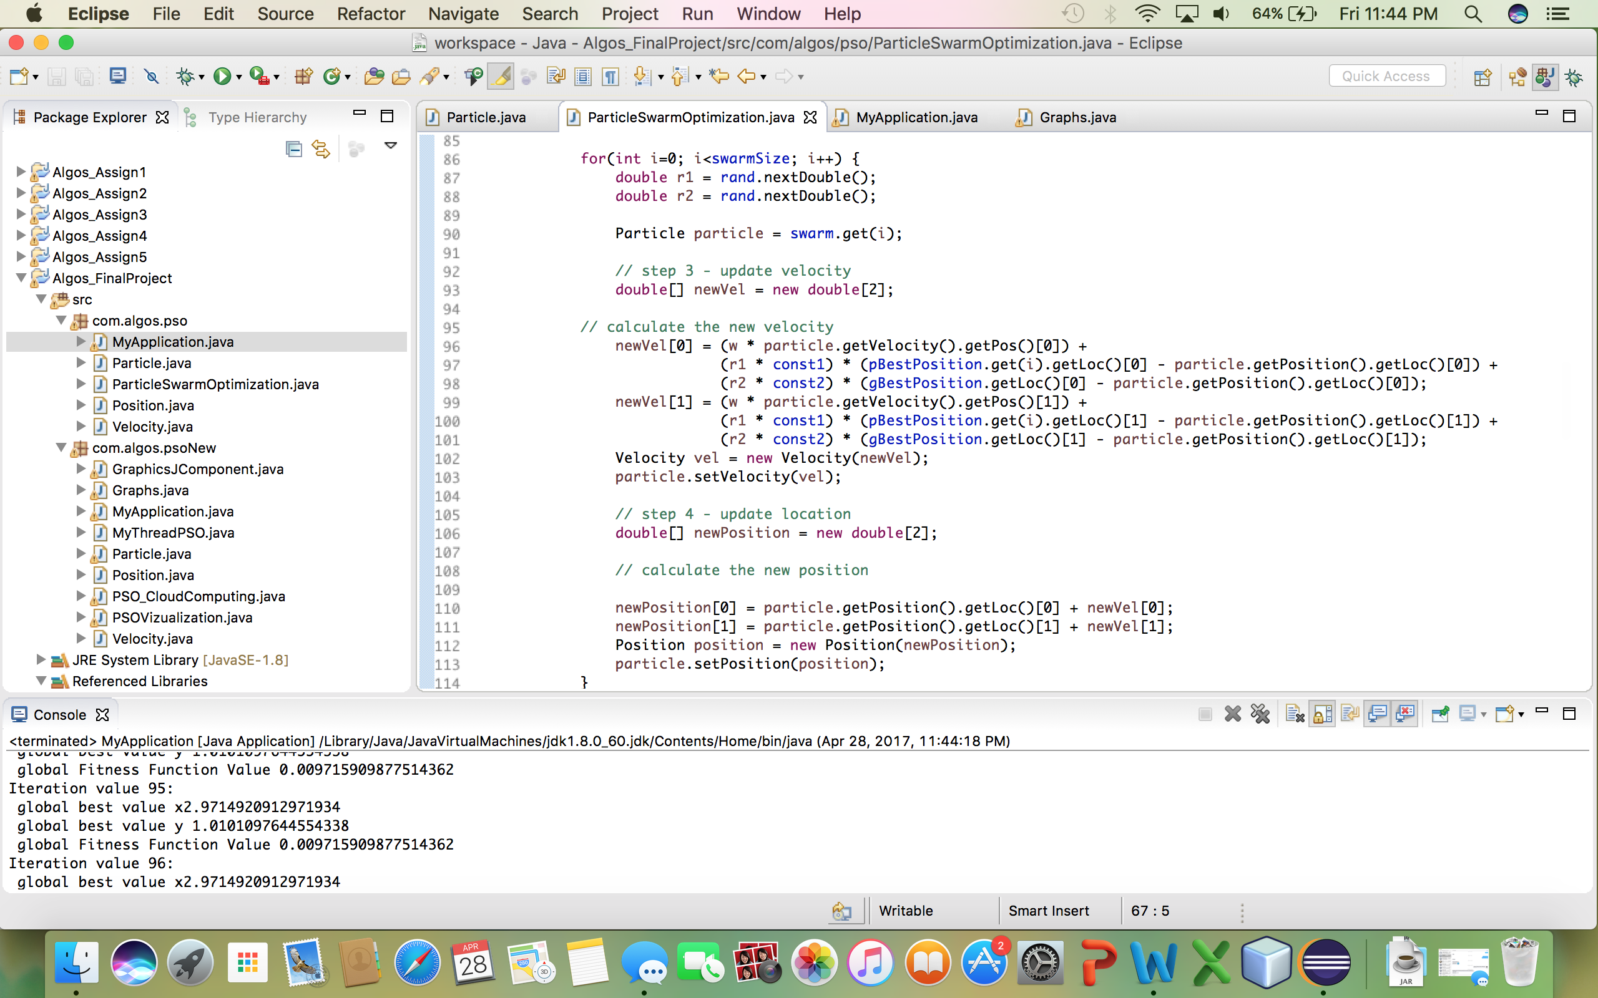

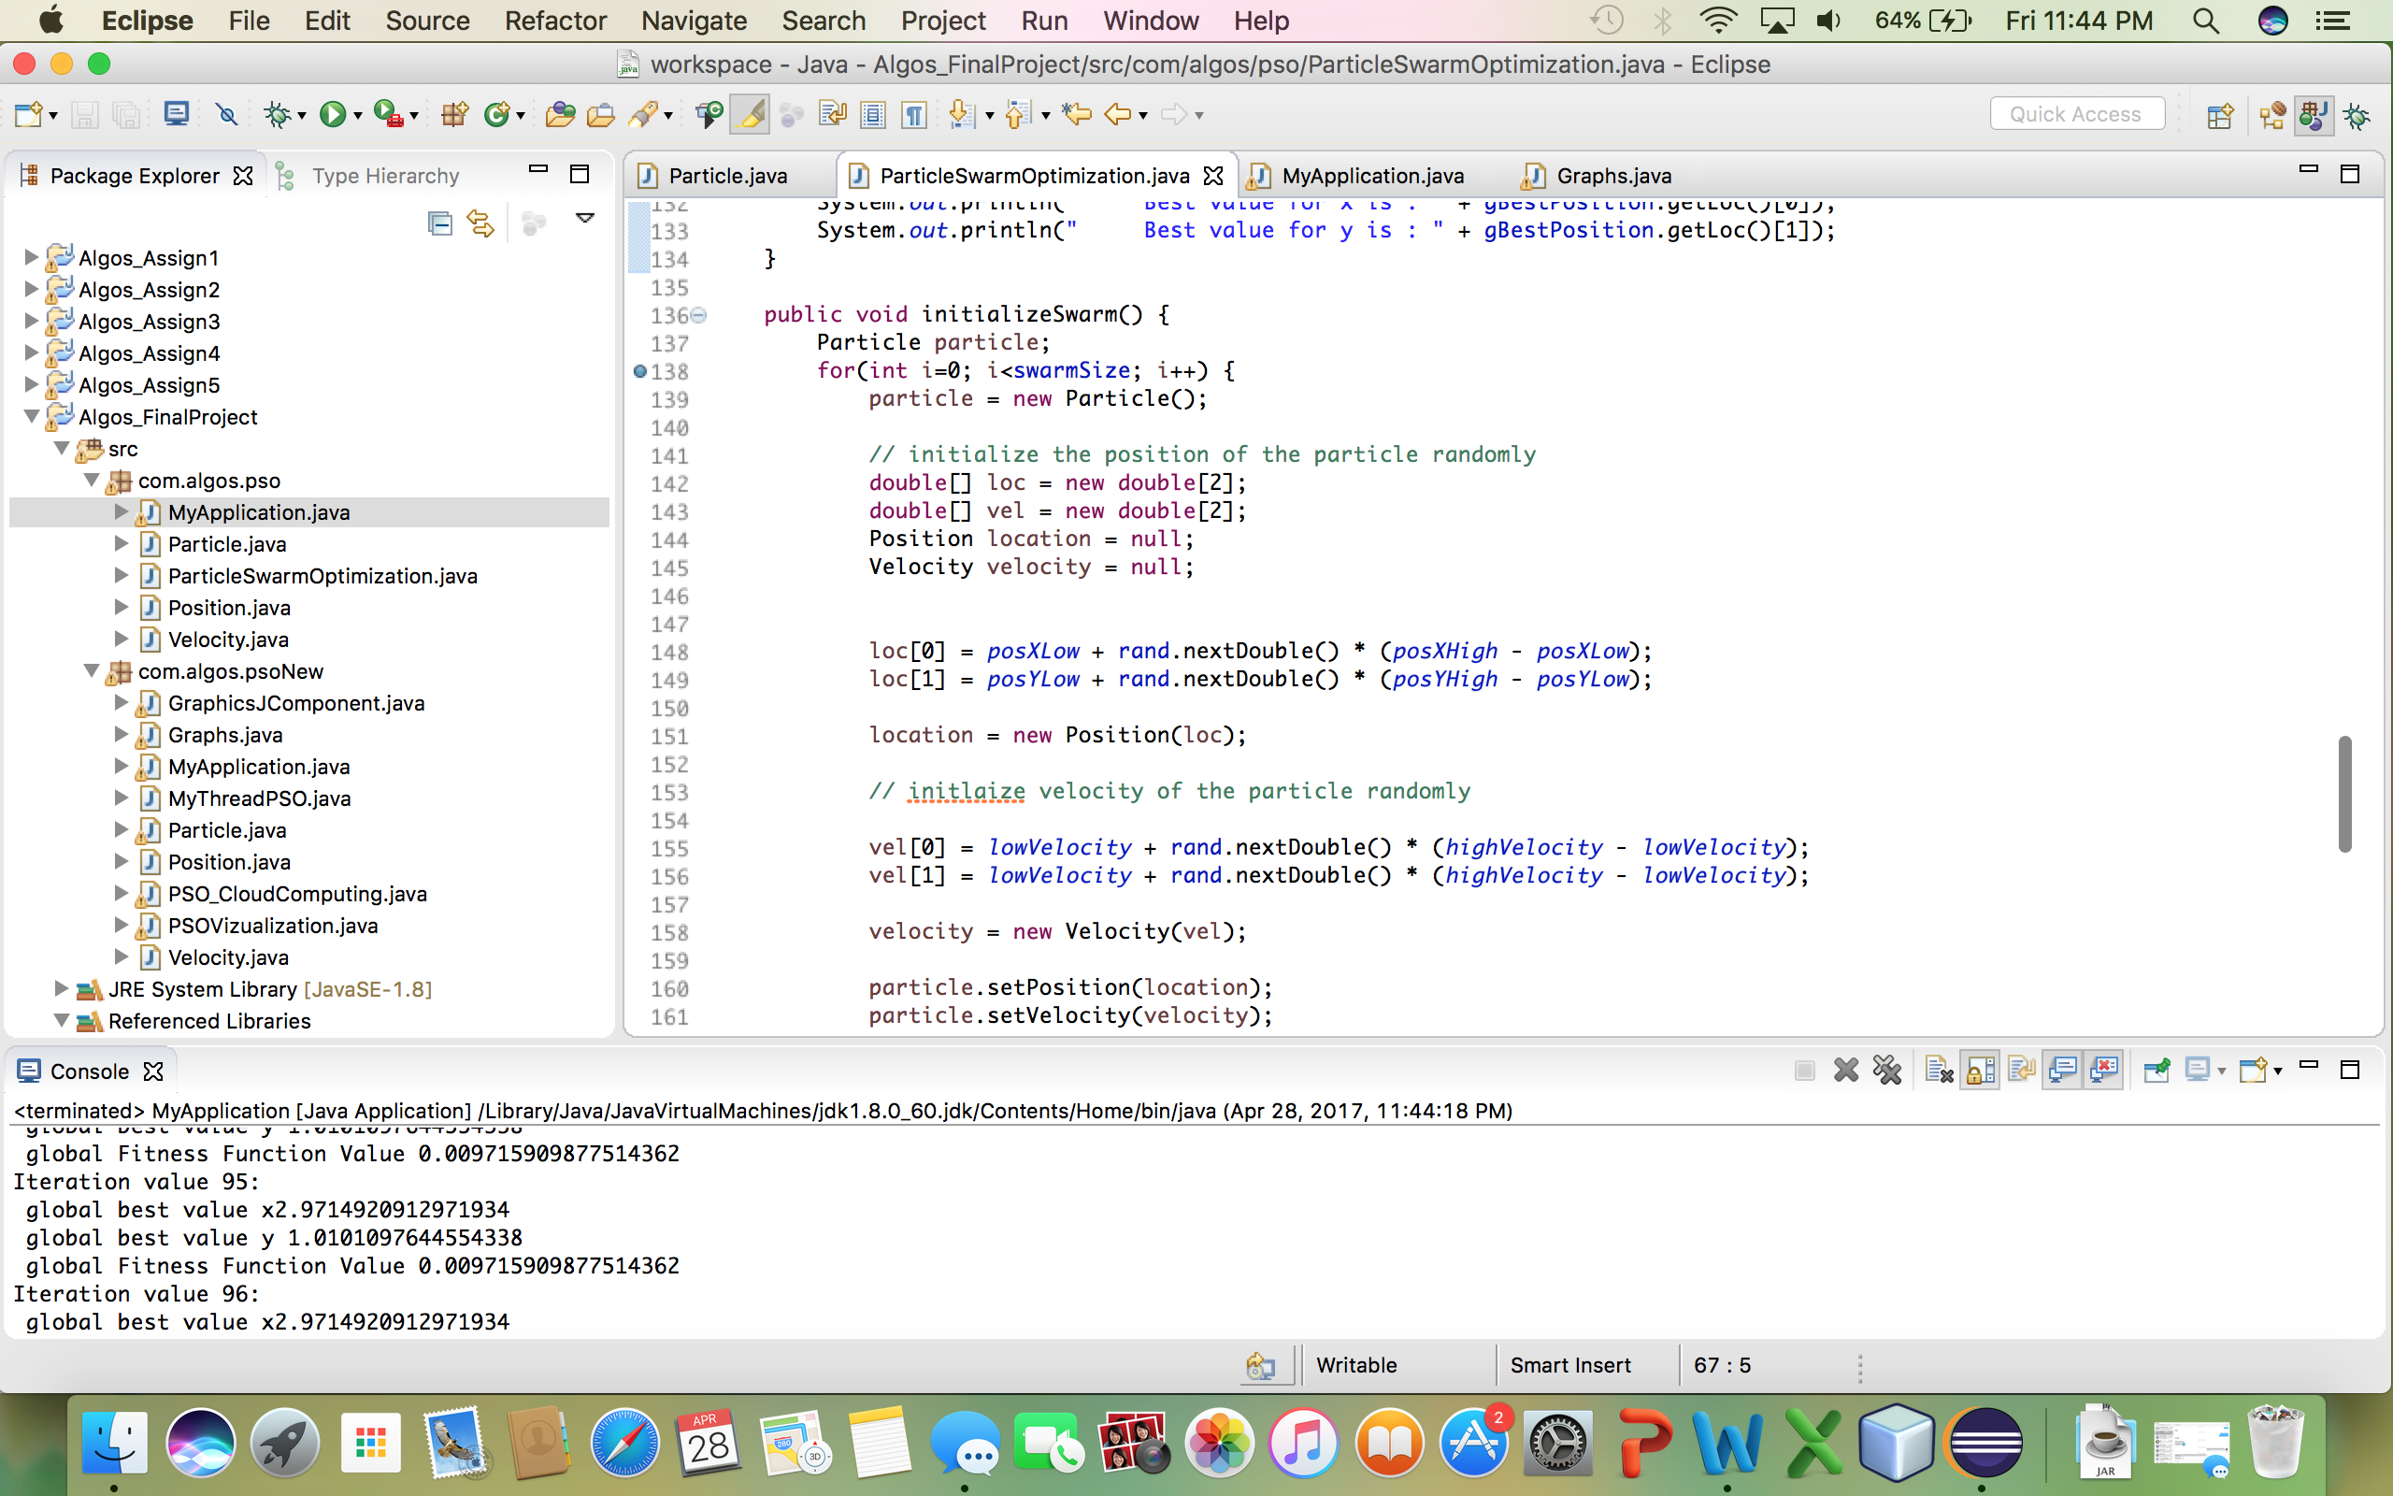

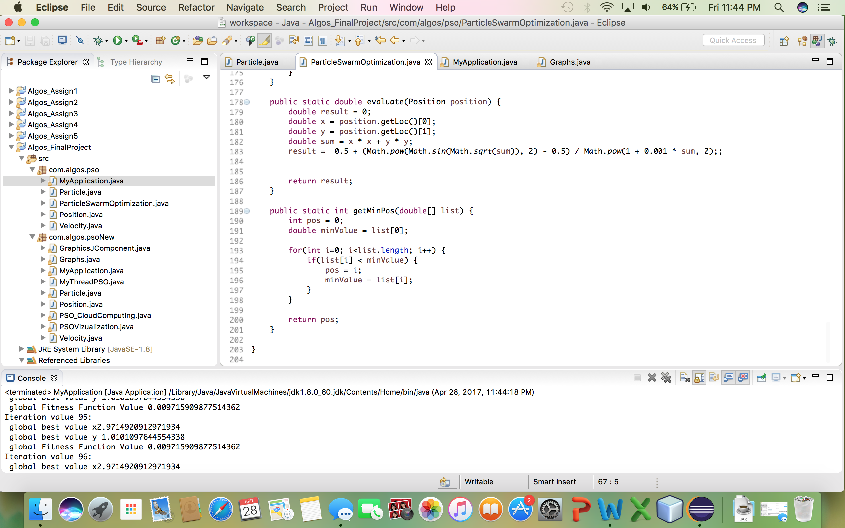

Particle.java

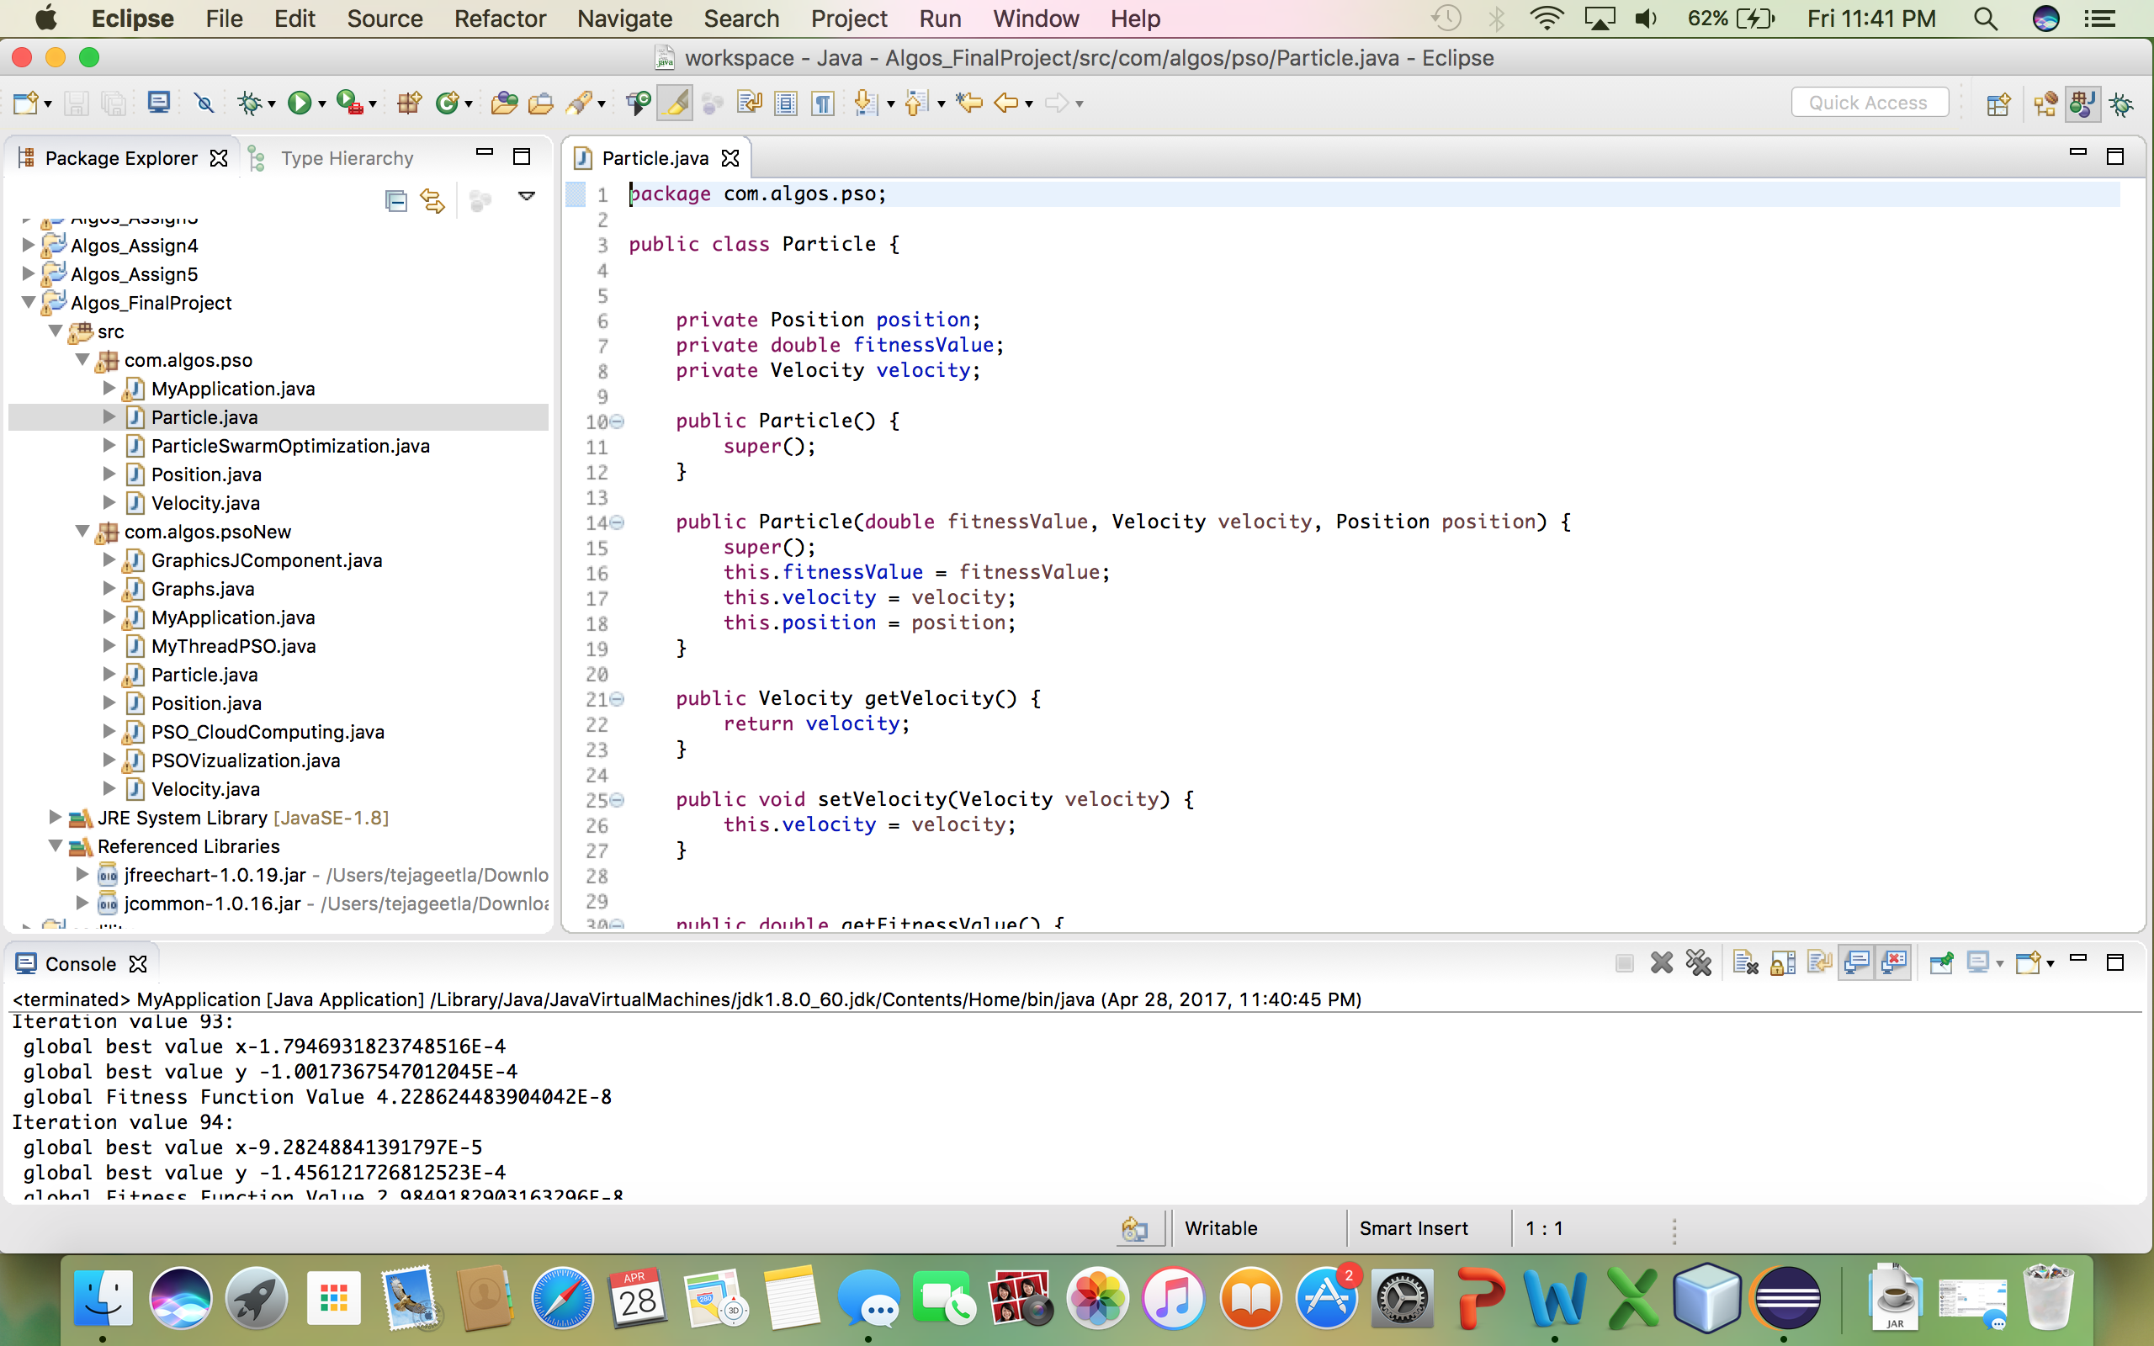

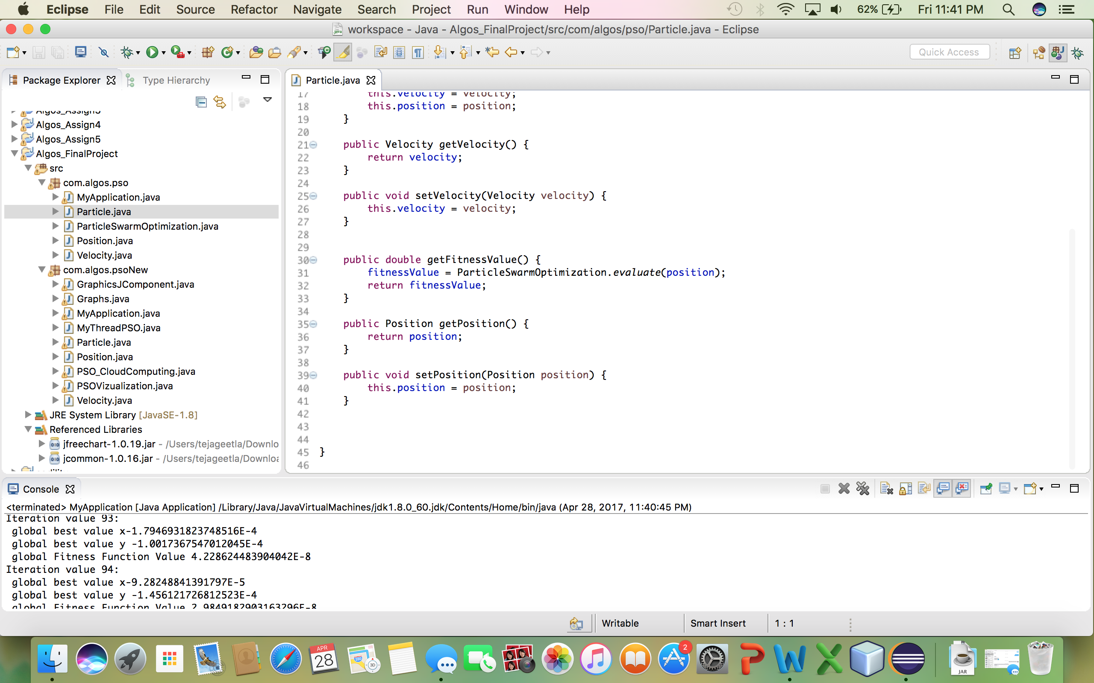

Graphs.java

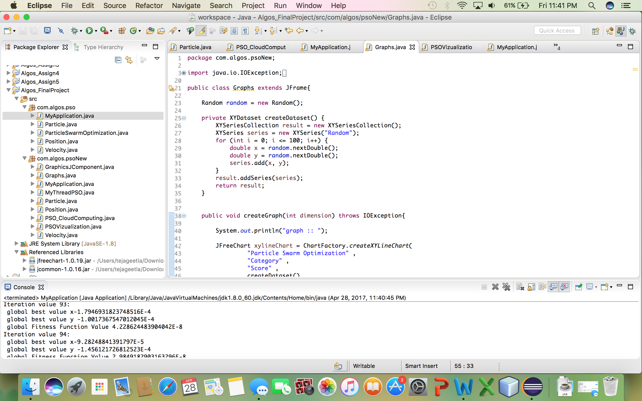

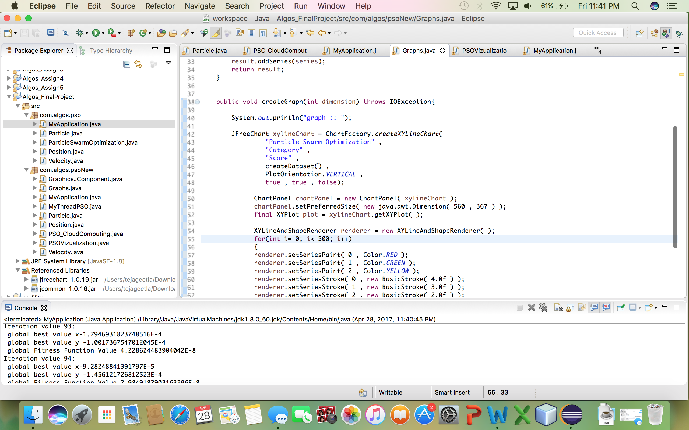

MyApplication.java

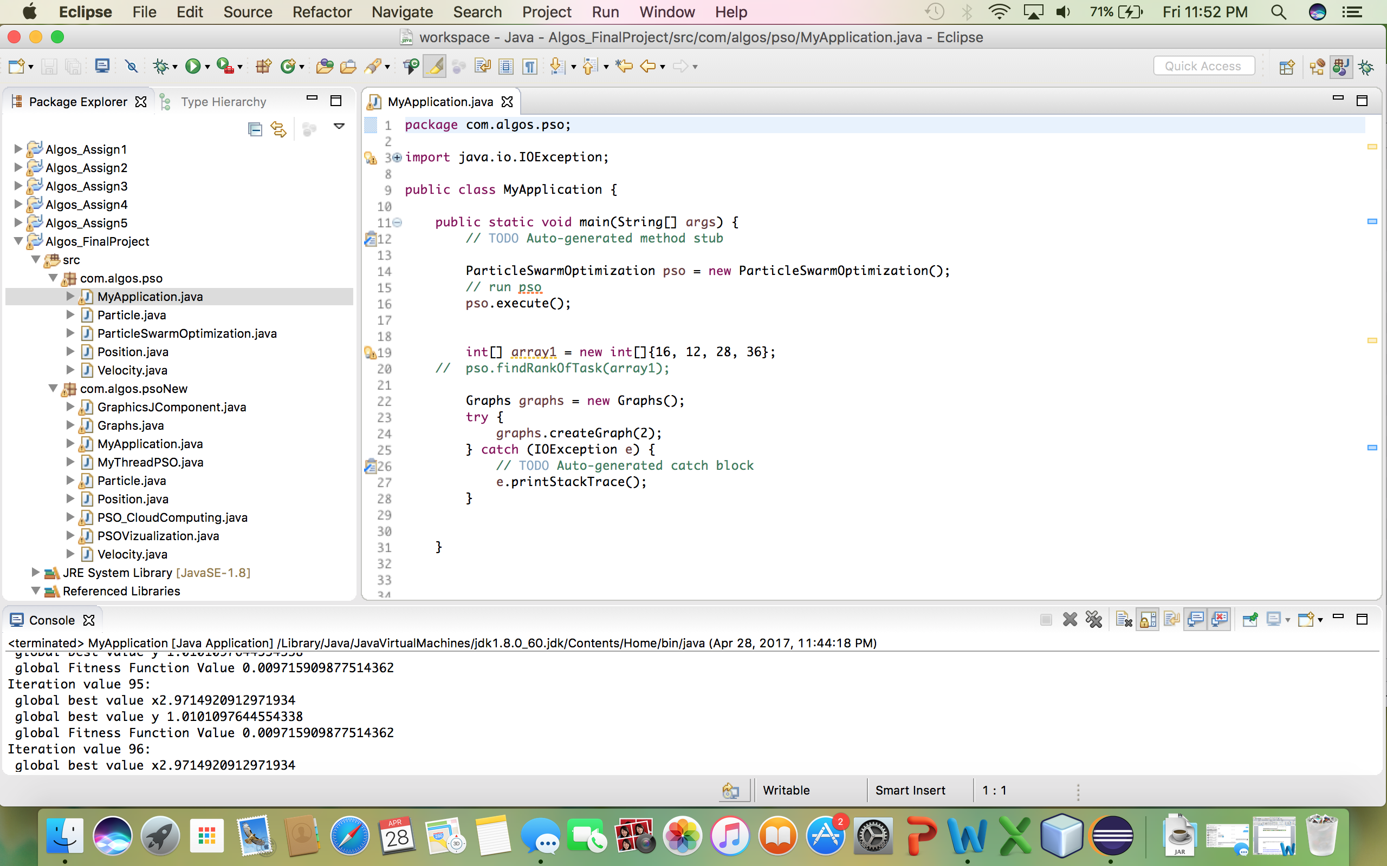

Output:

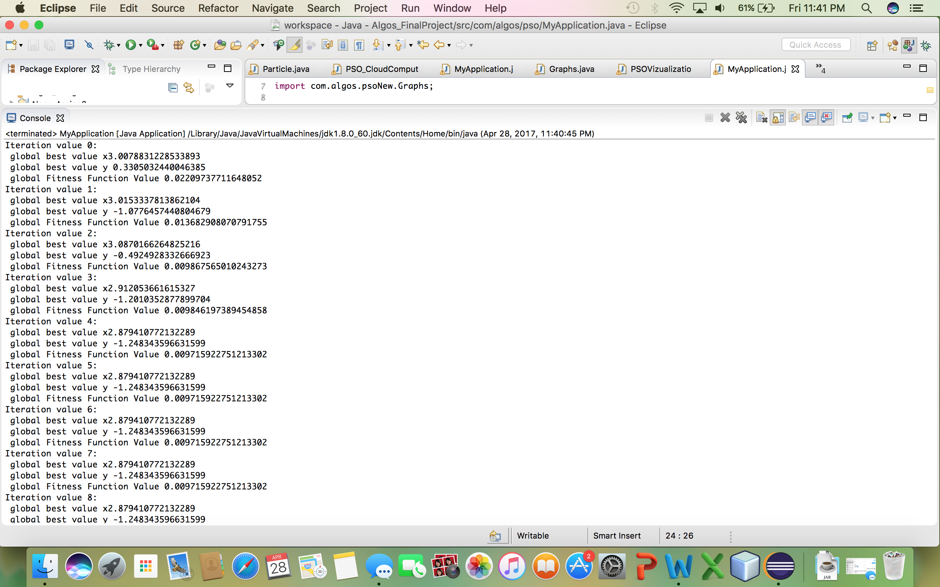

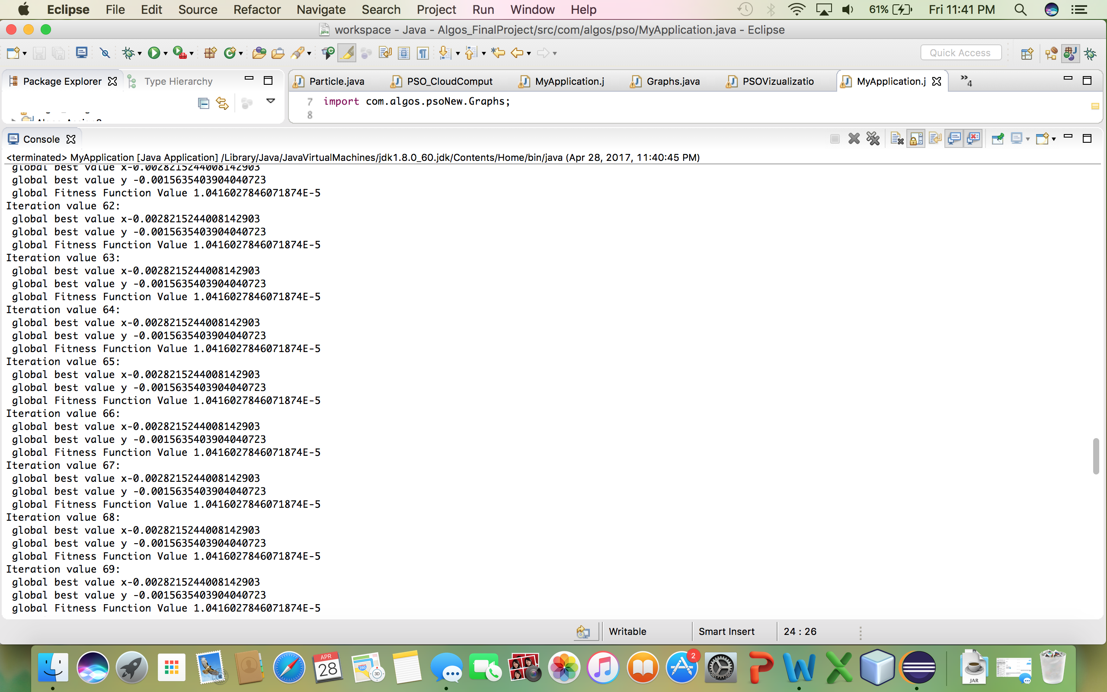

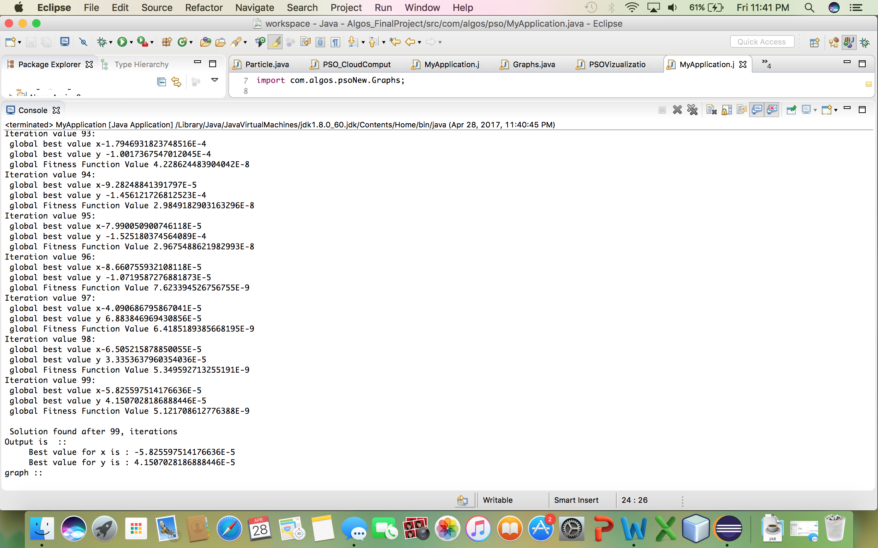

Graph:

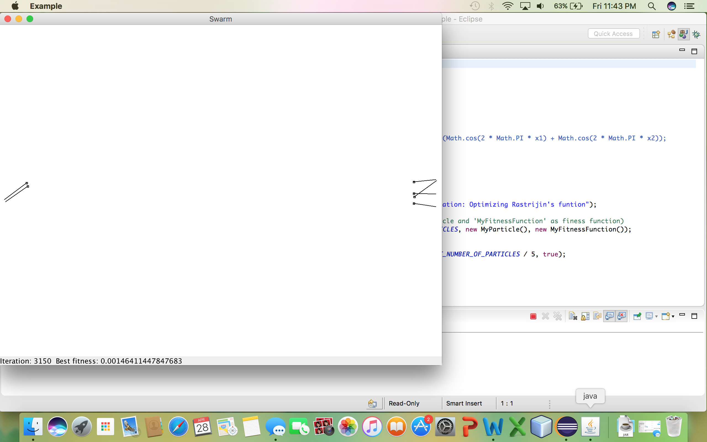

In the second method I used constraints for max and min velocity and position.

In this approach I used rank for the position vector, based on that I ordered my task.

Particle.java

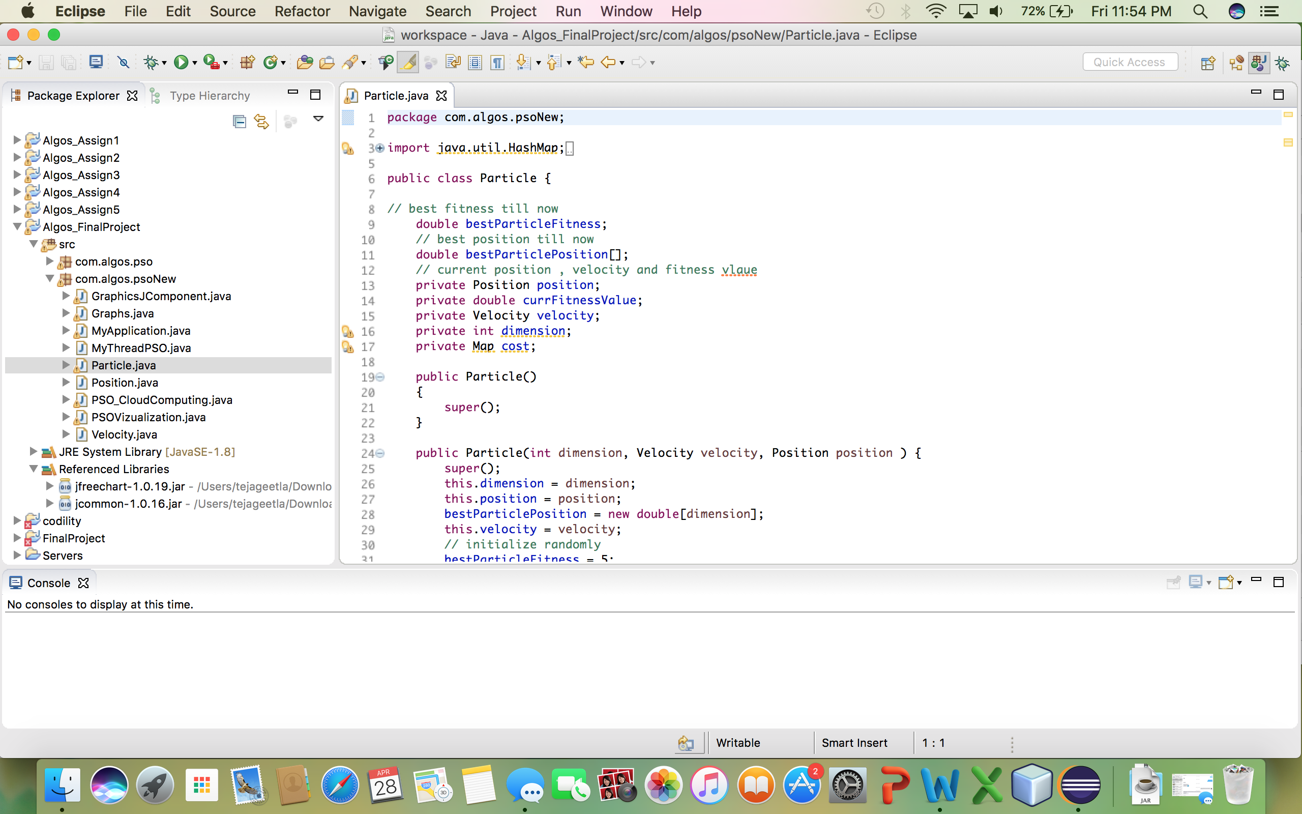

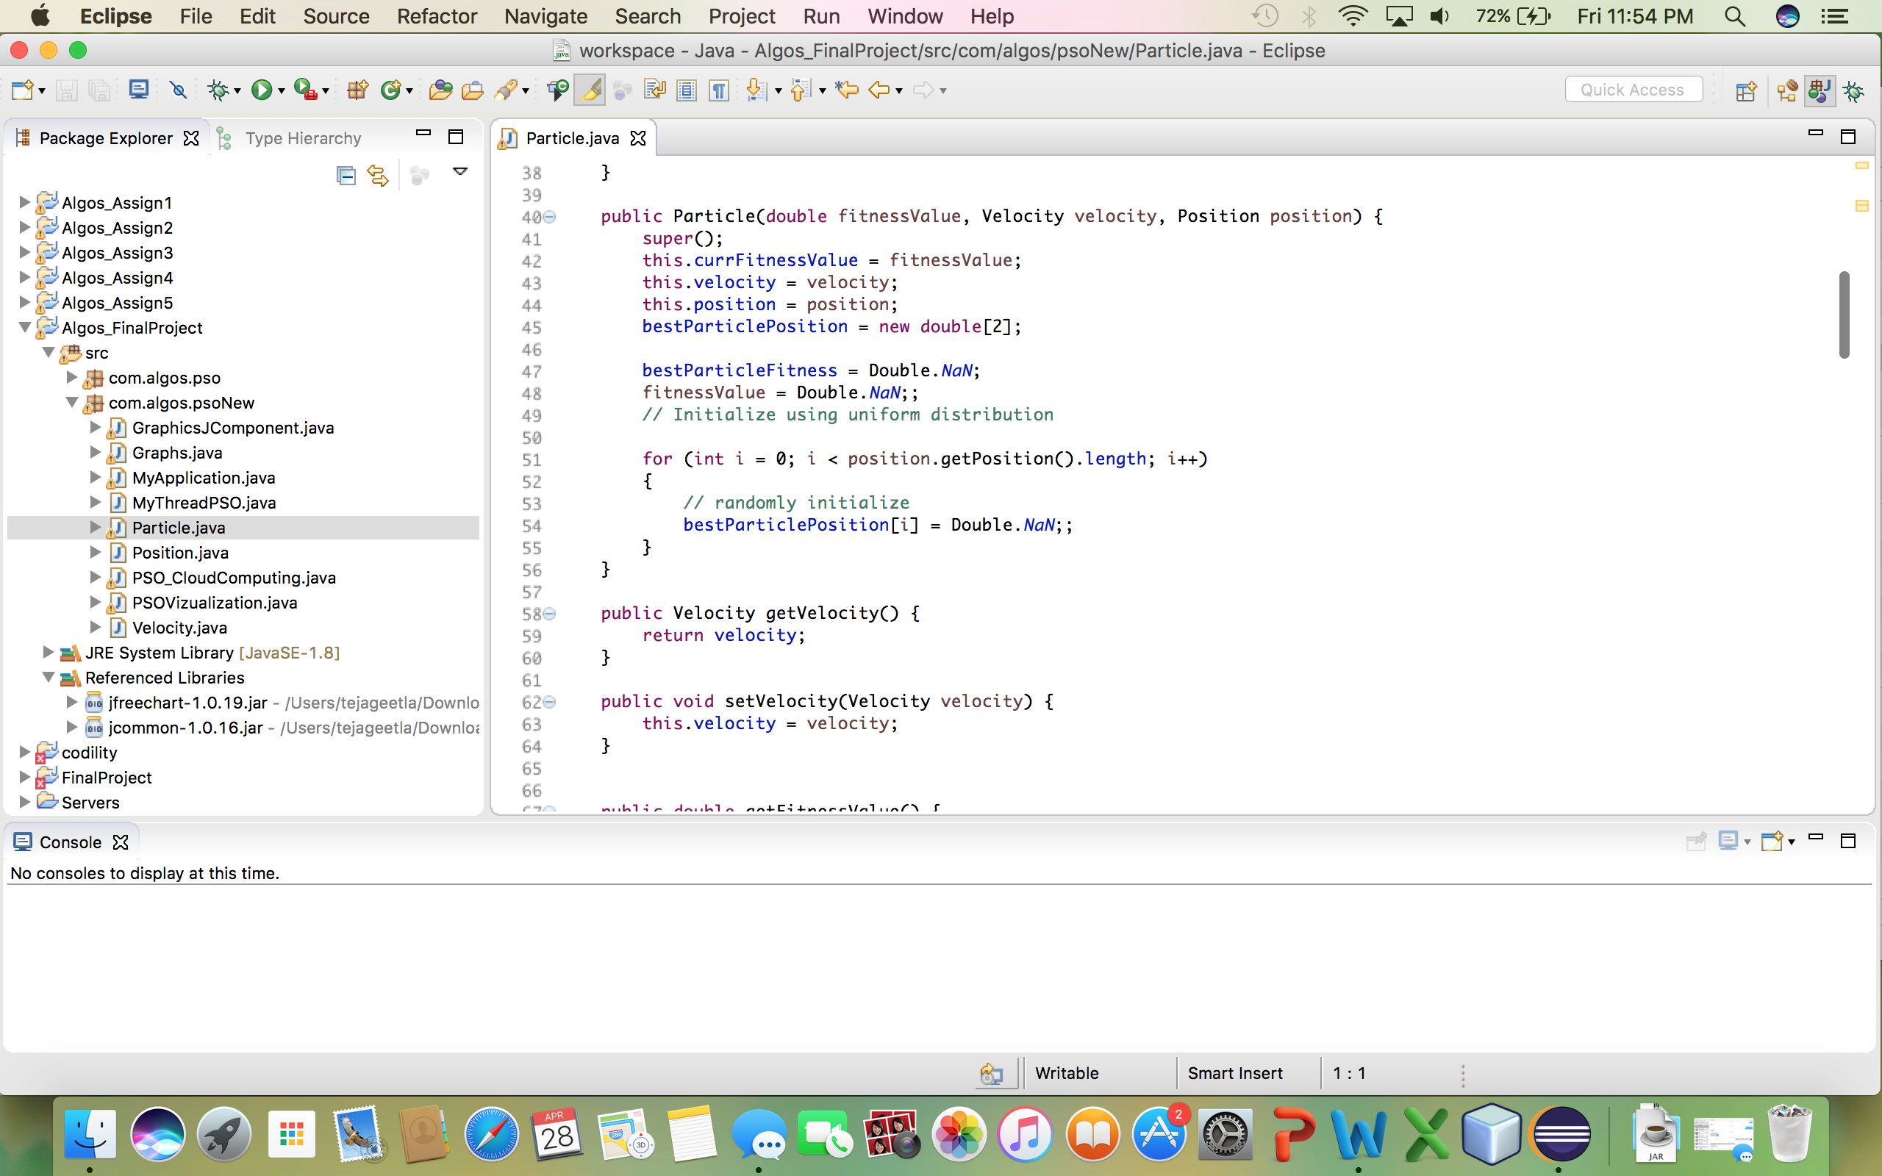

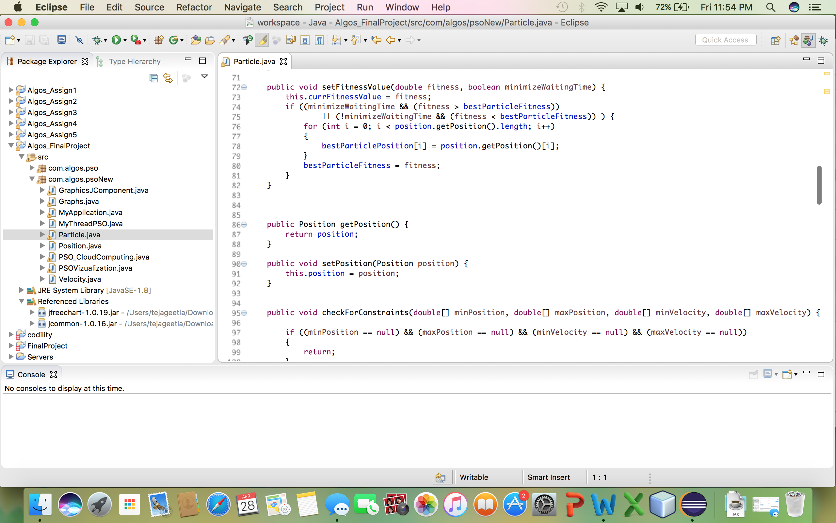

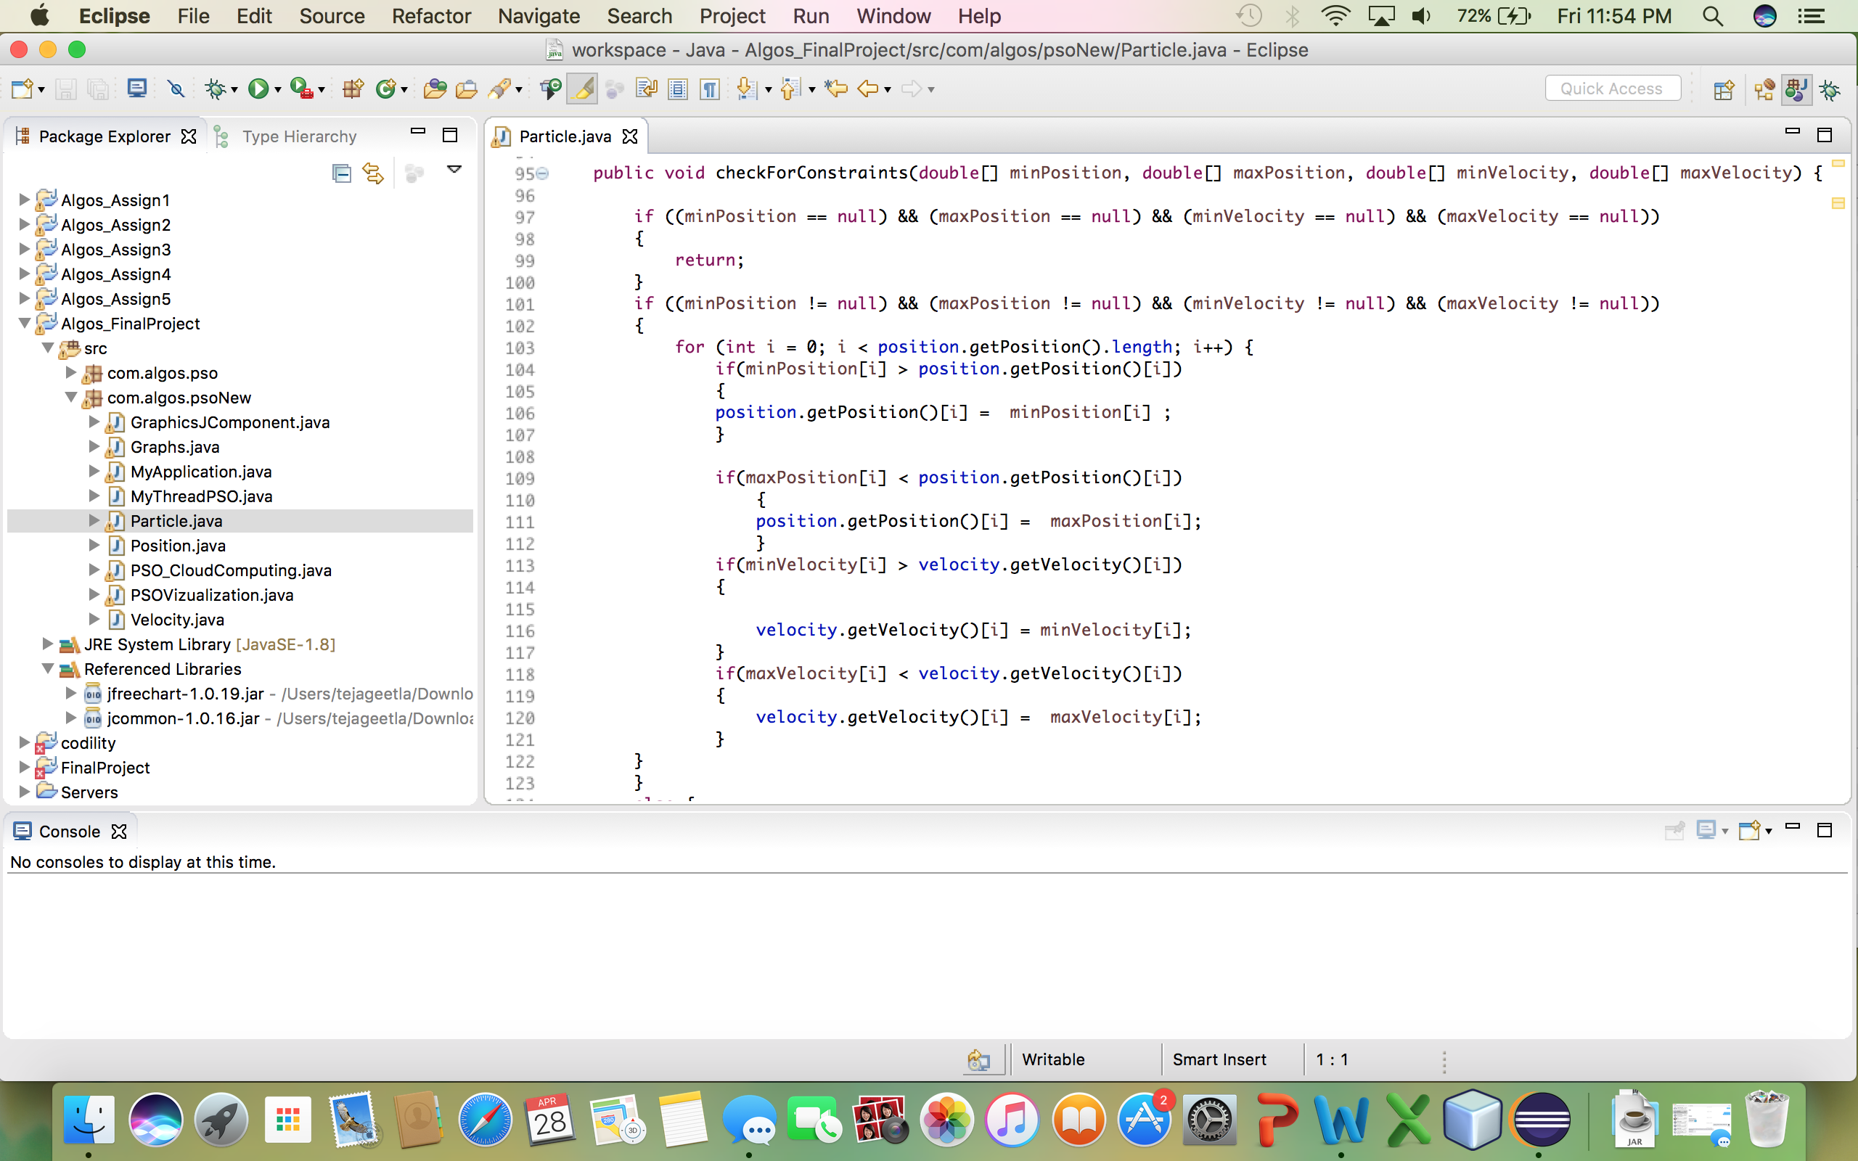

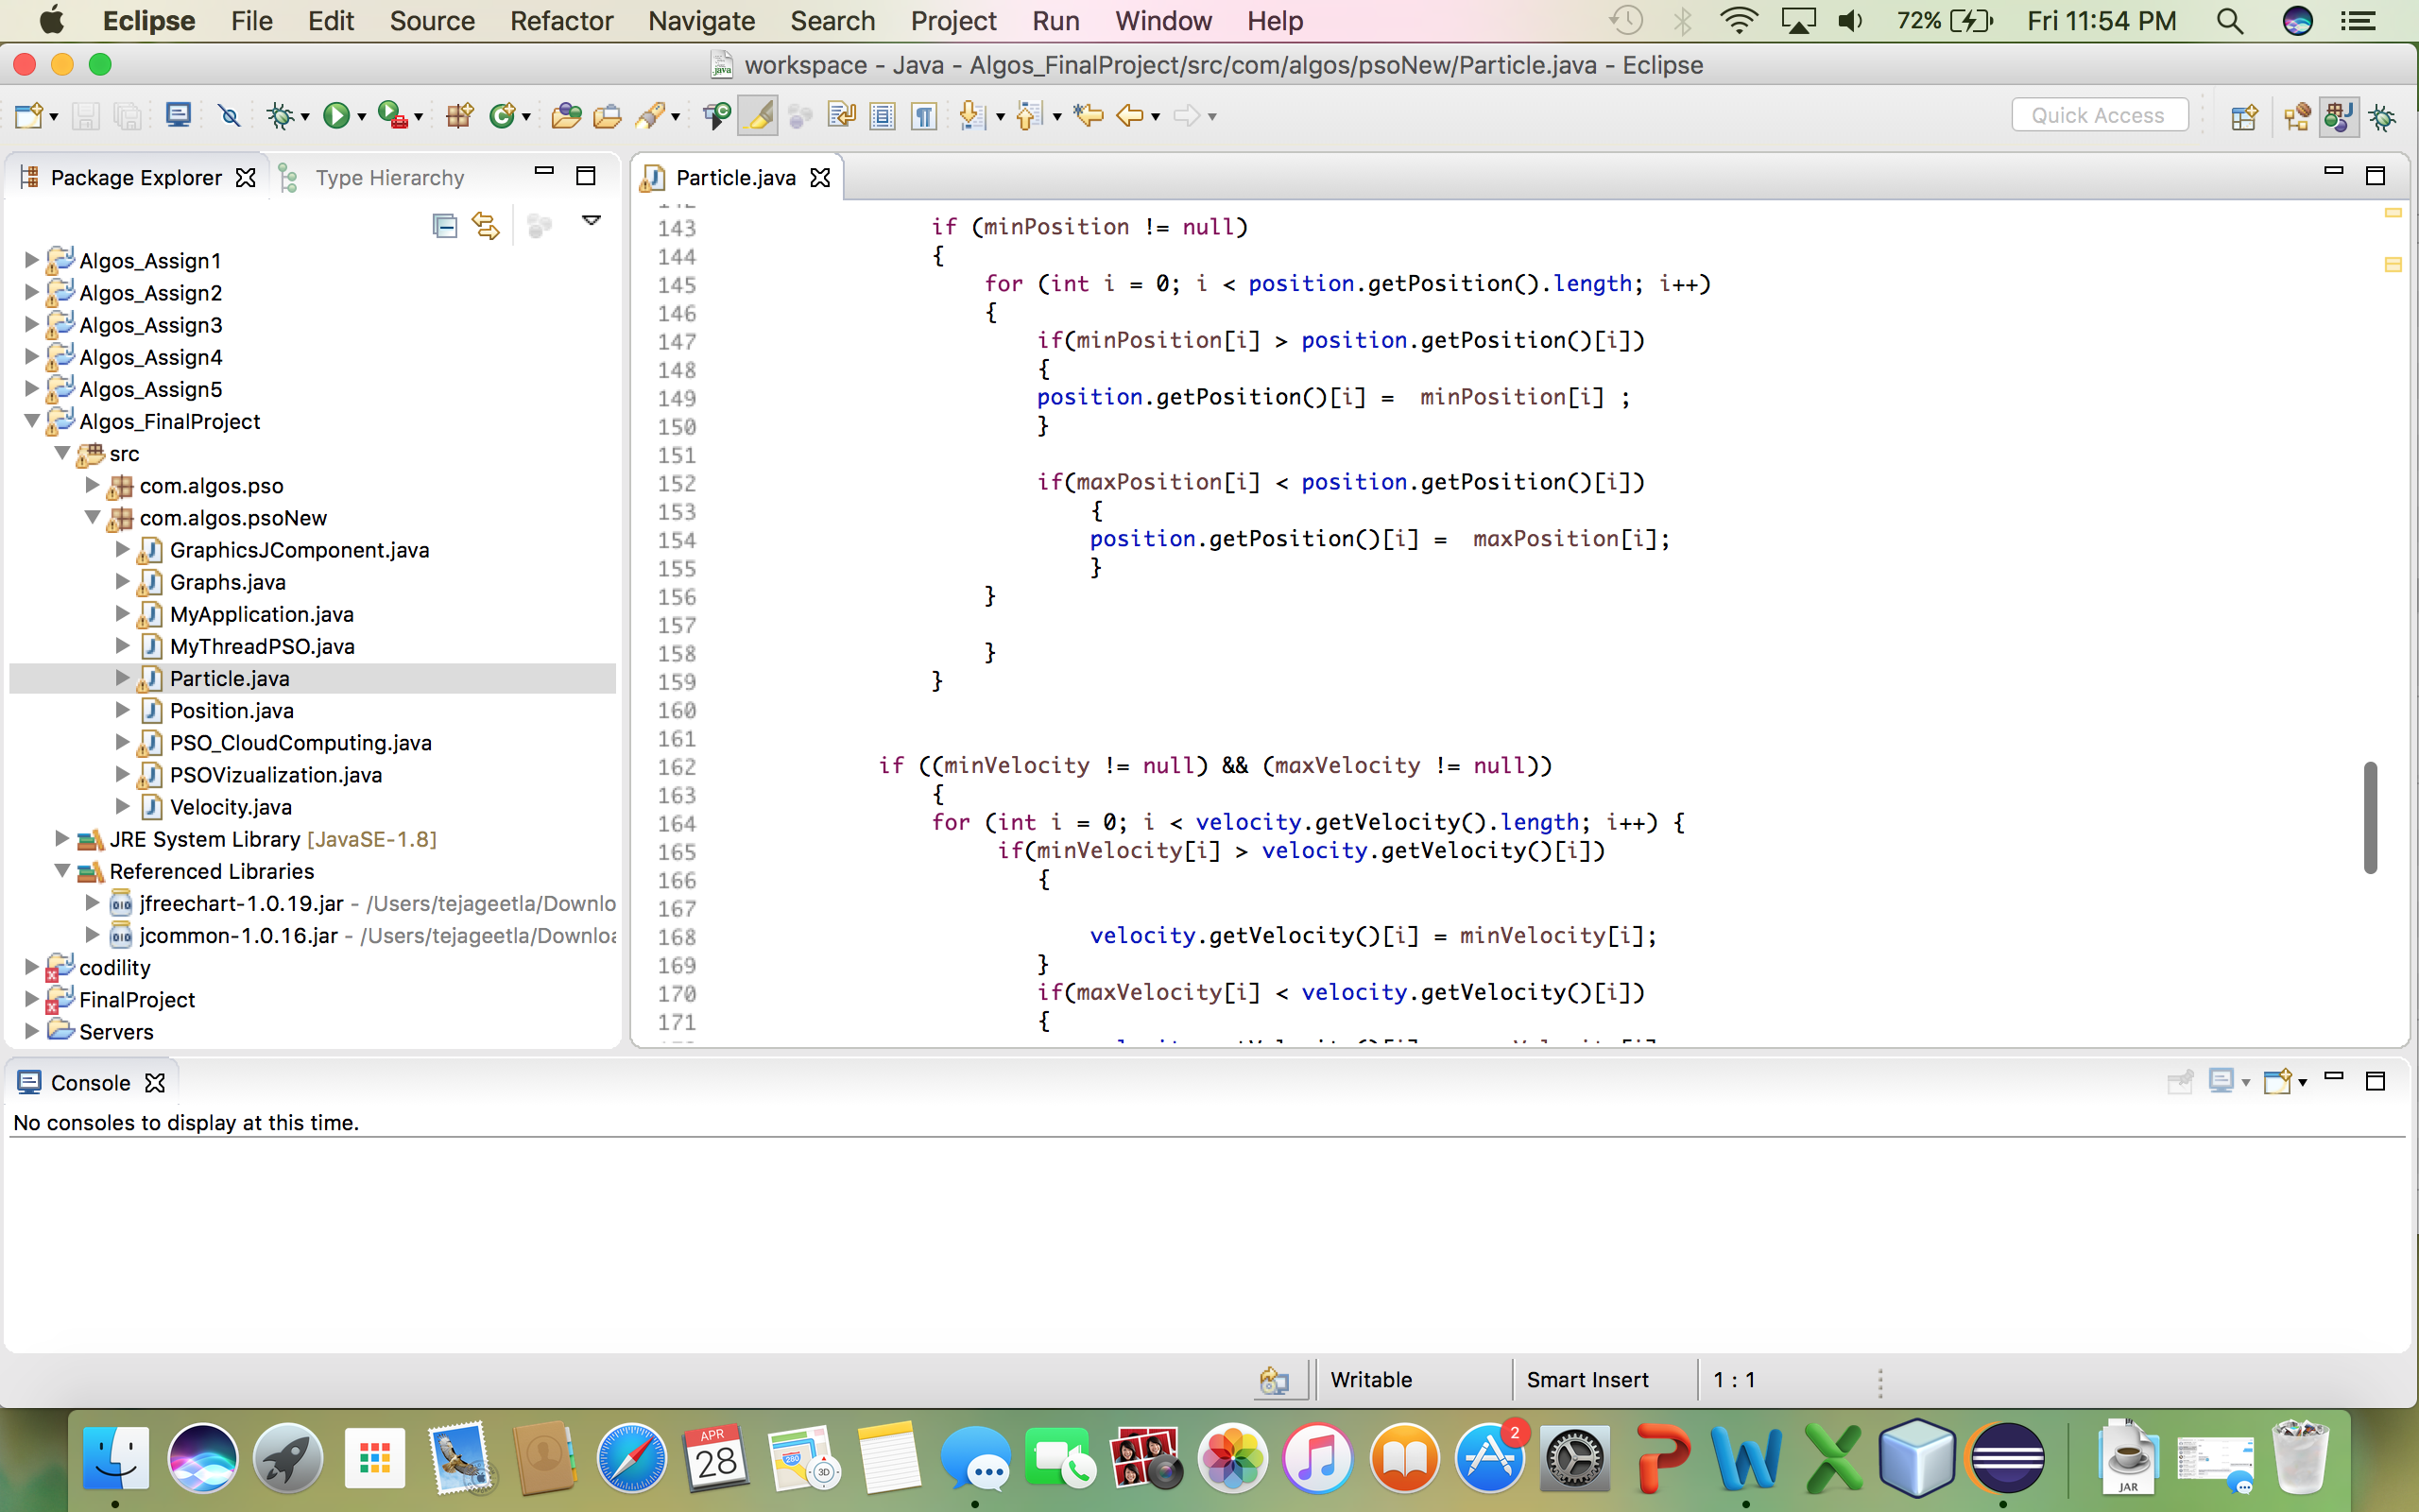

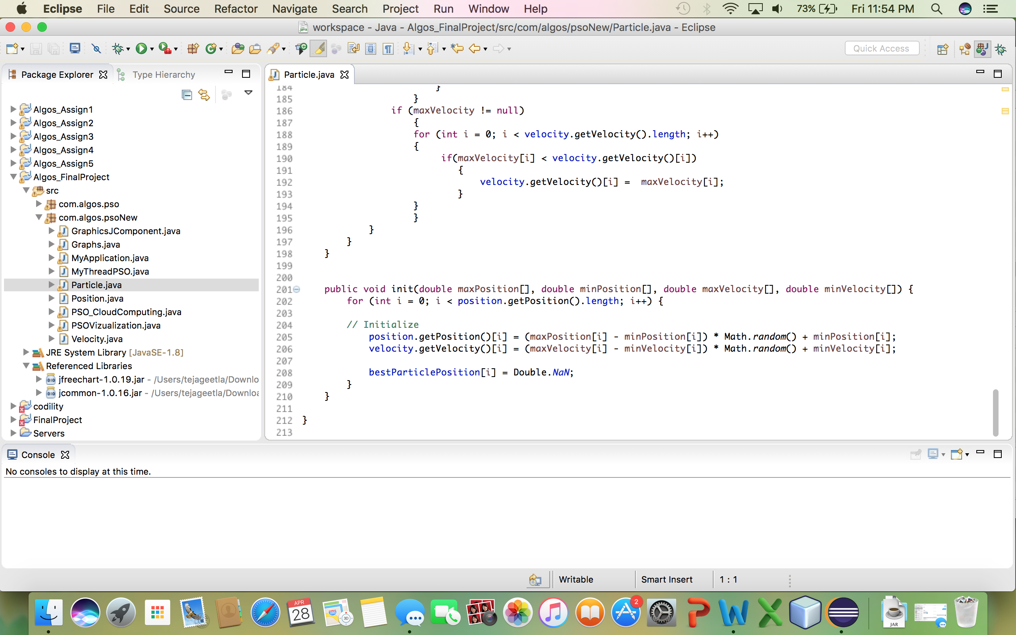

PSOVizualization.java

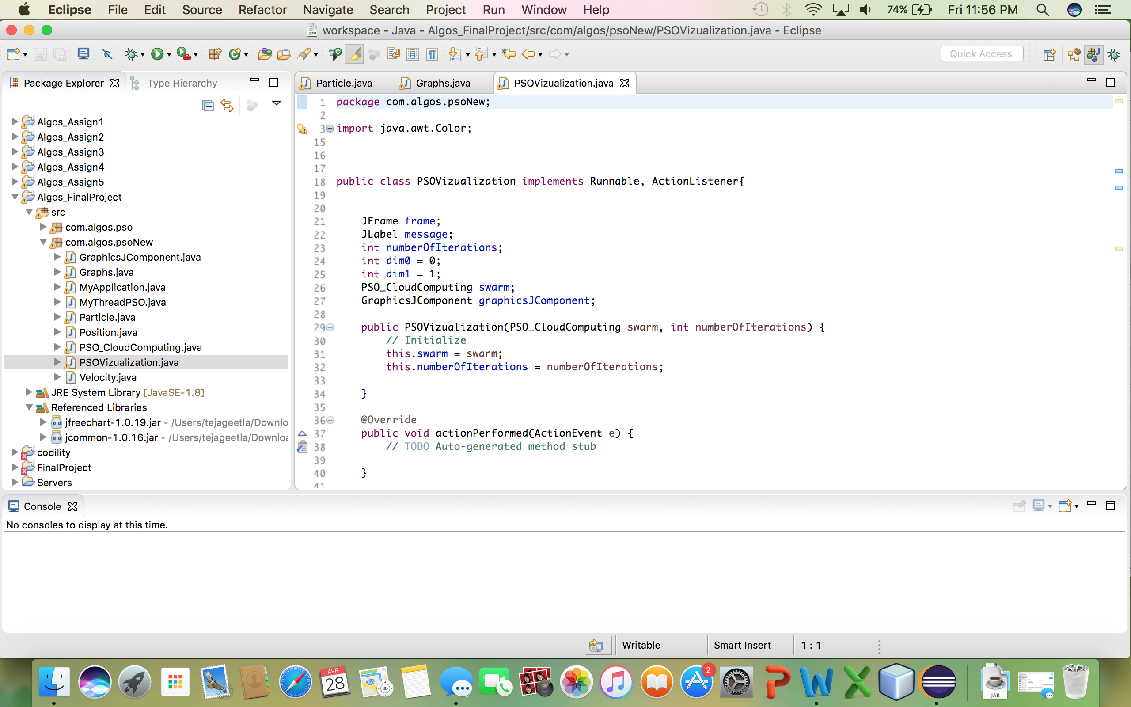

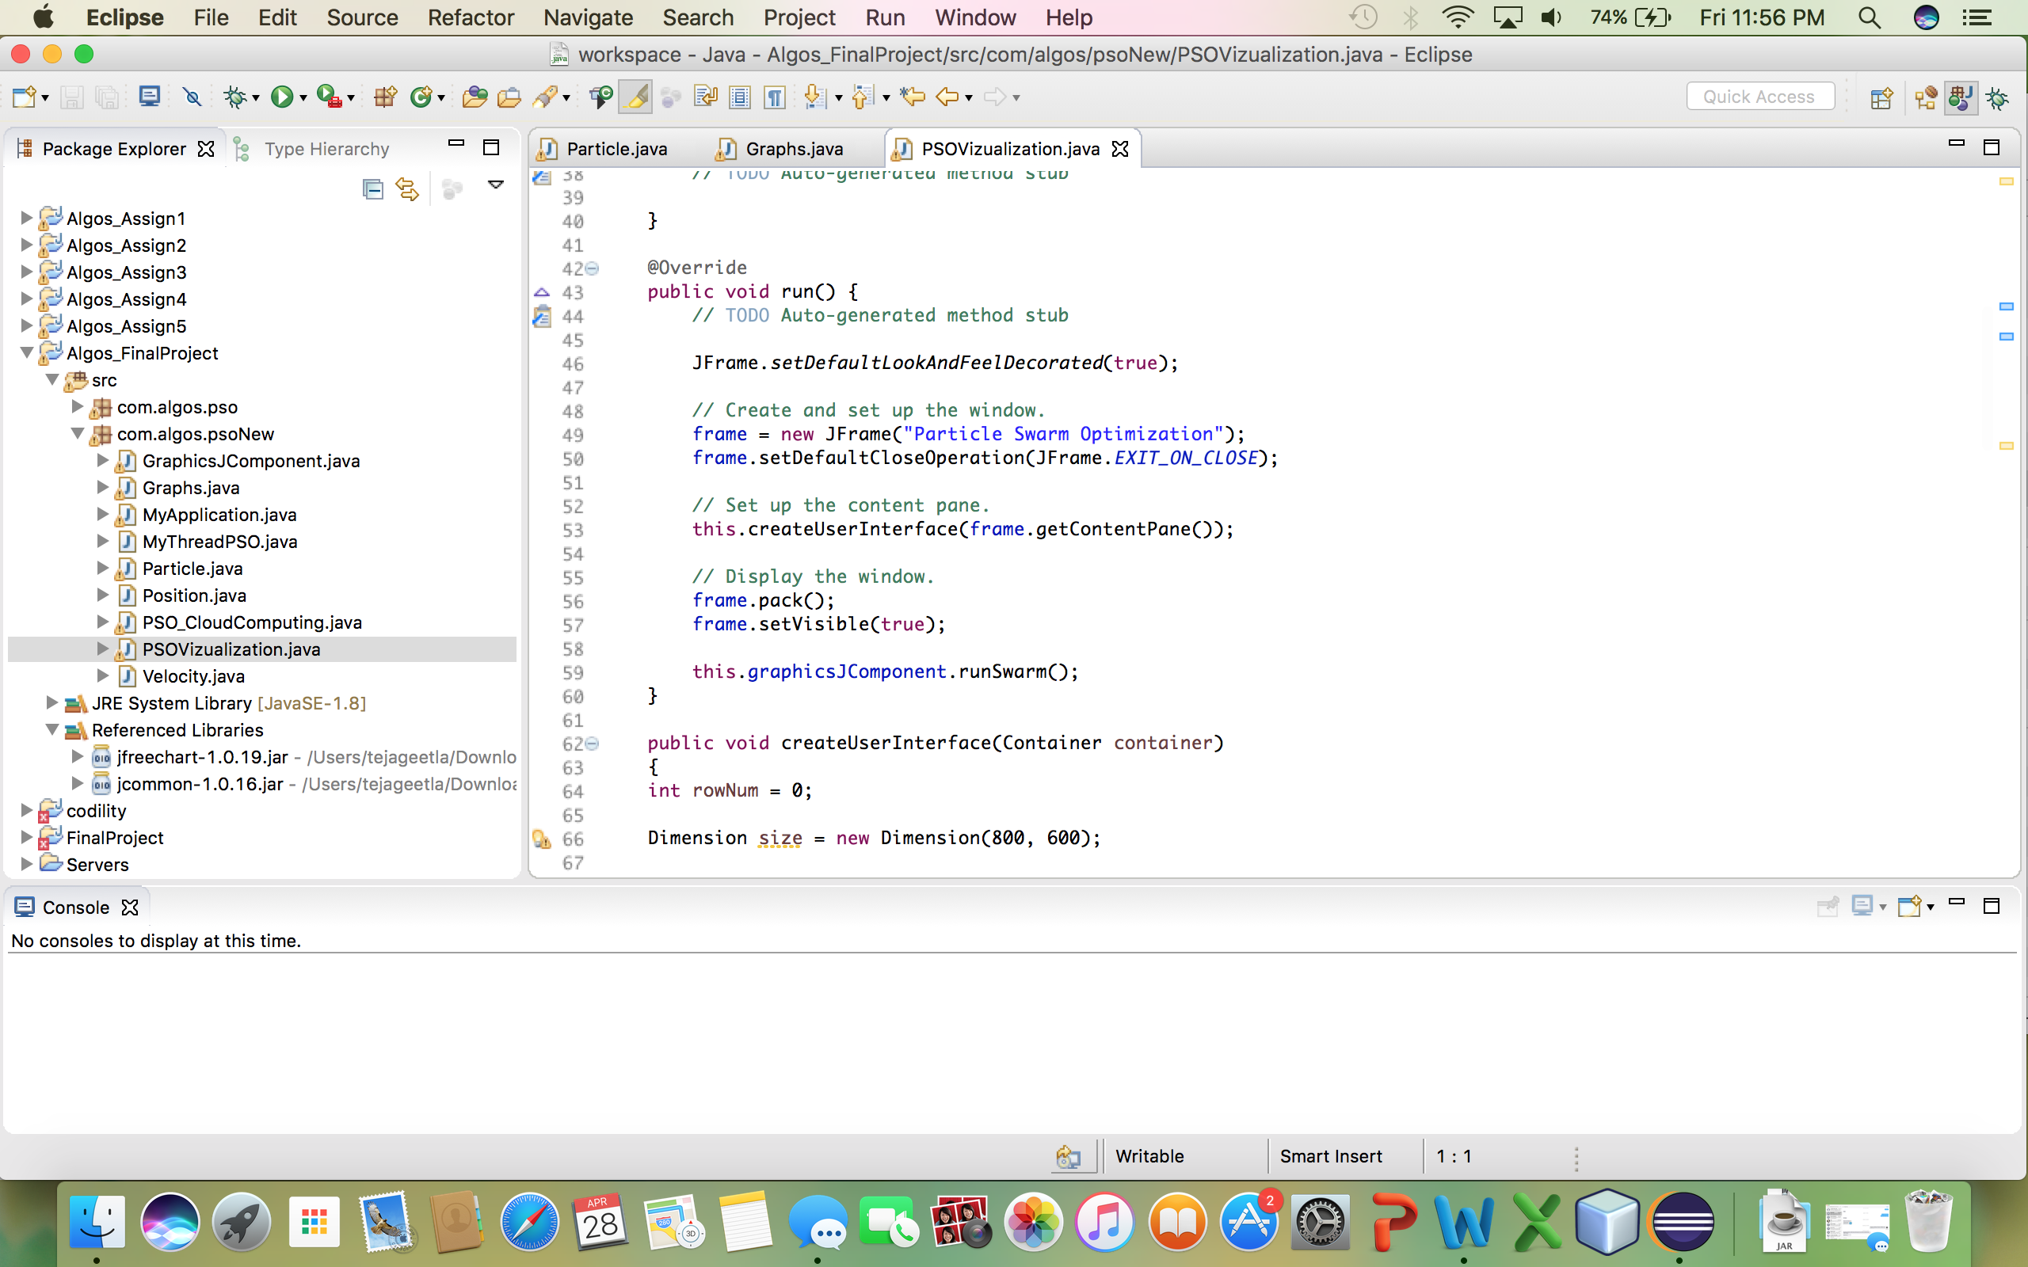

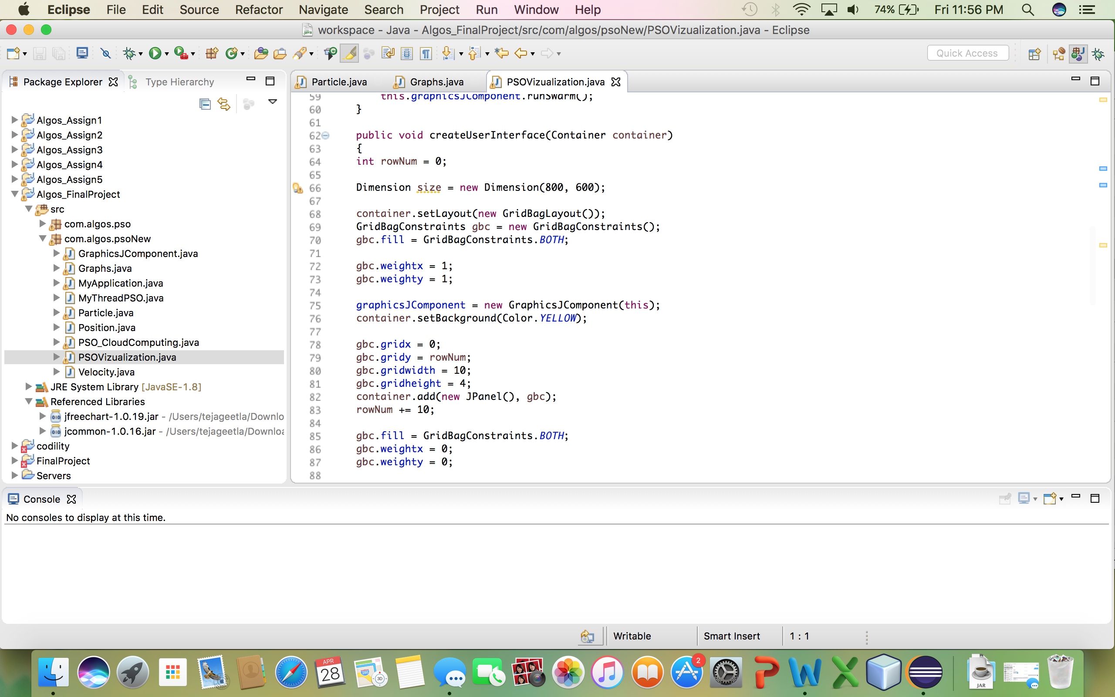

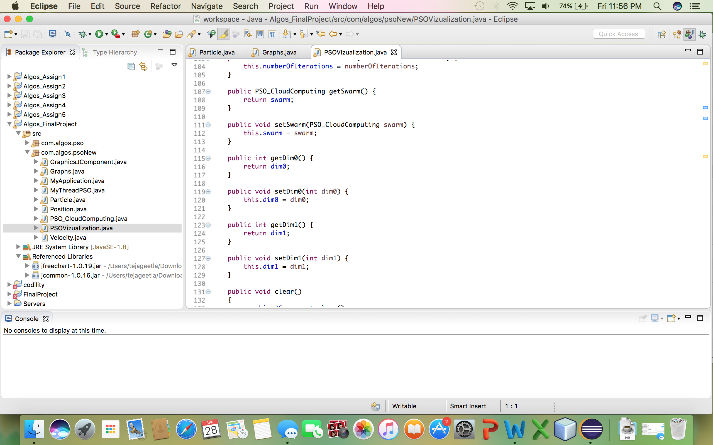

MyThreadPSO.java

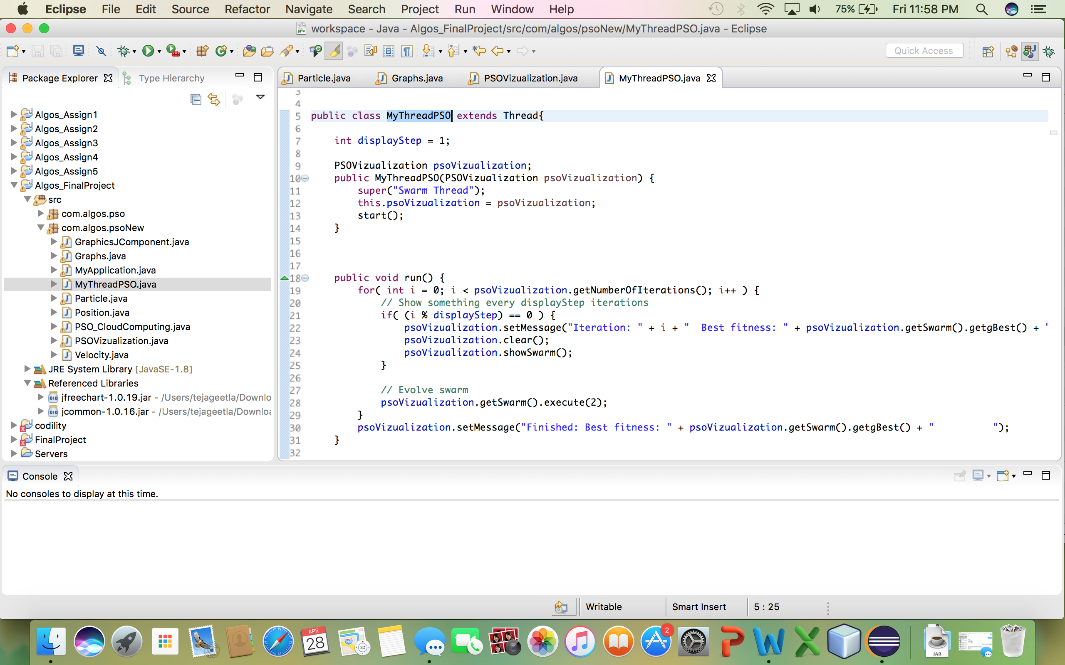

PSO_Cloudcomputing.java:

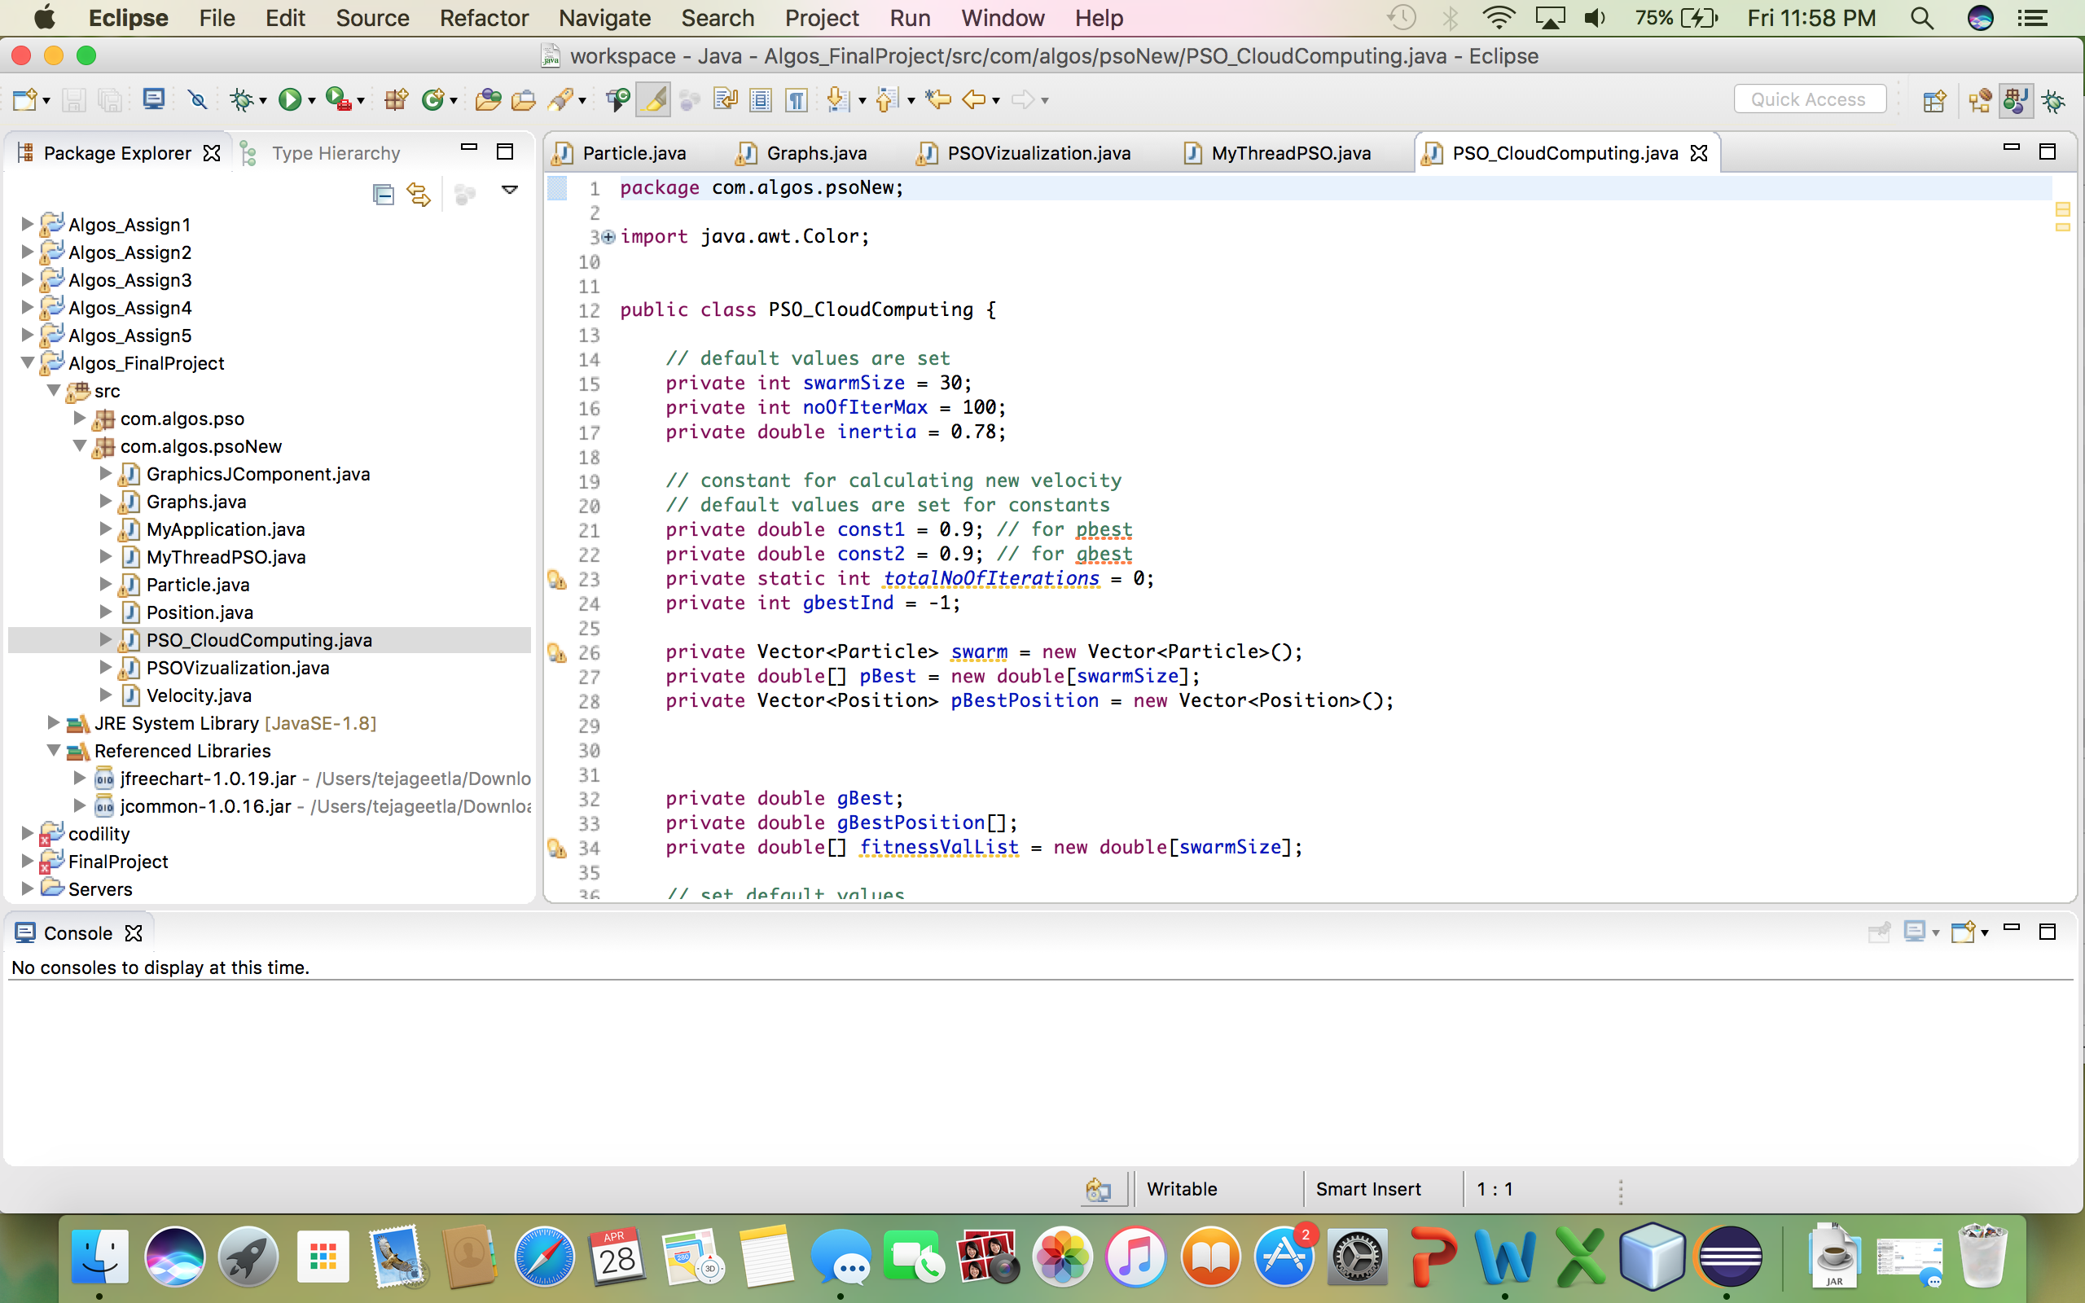

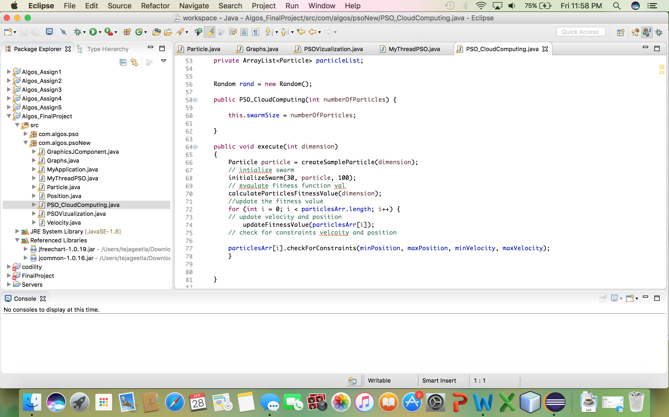

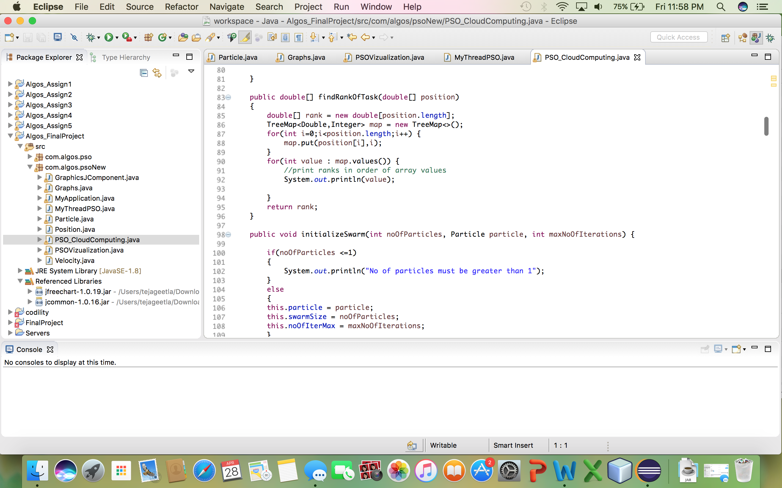

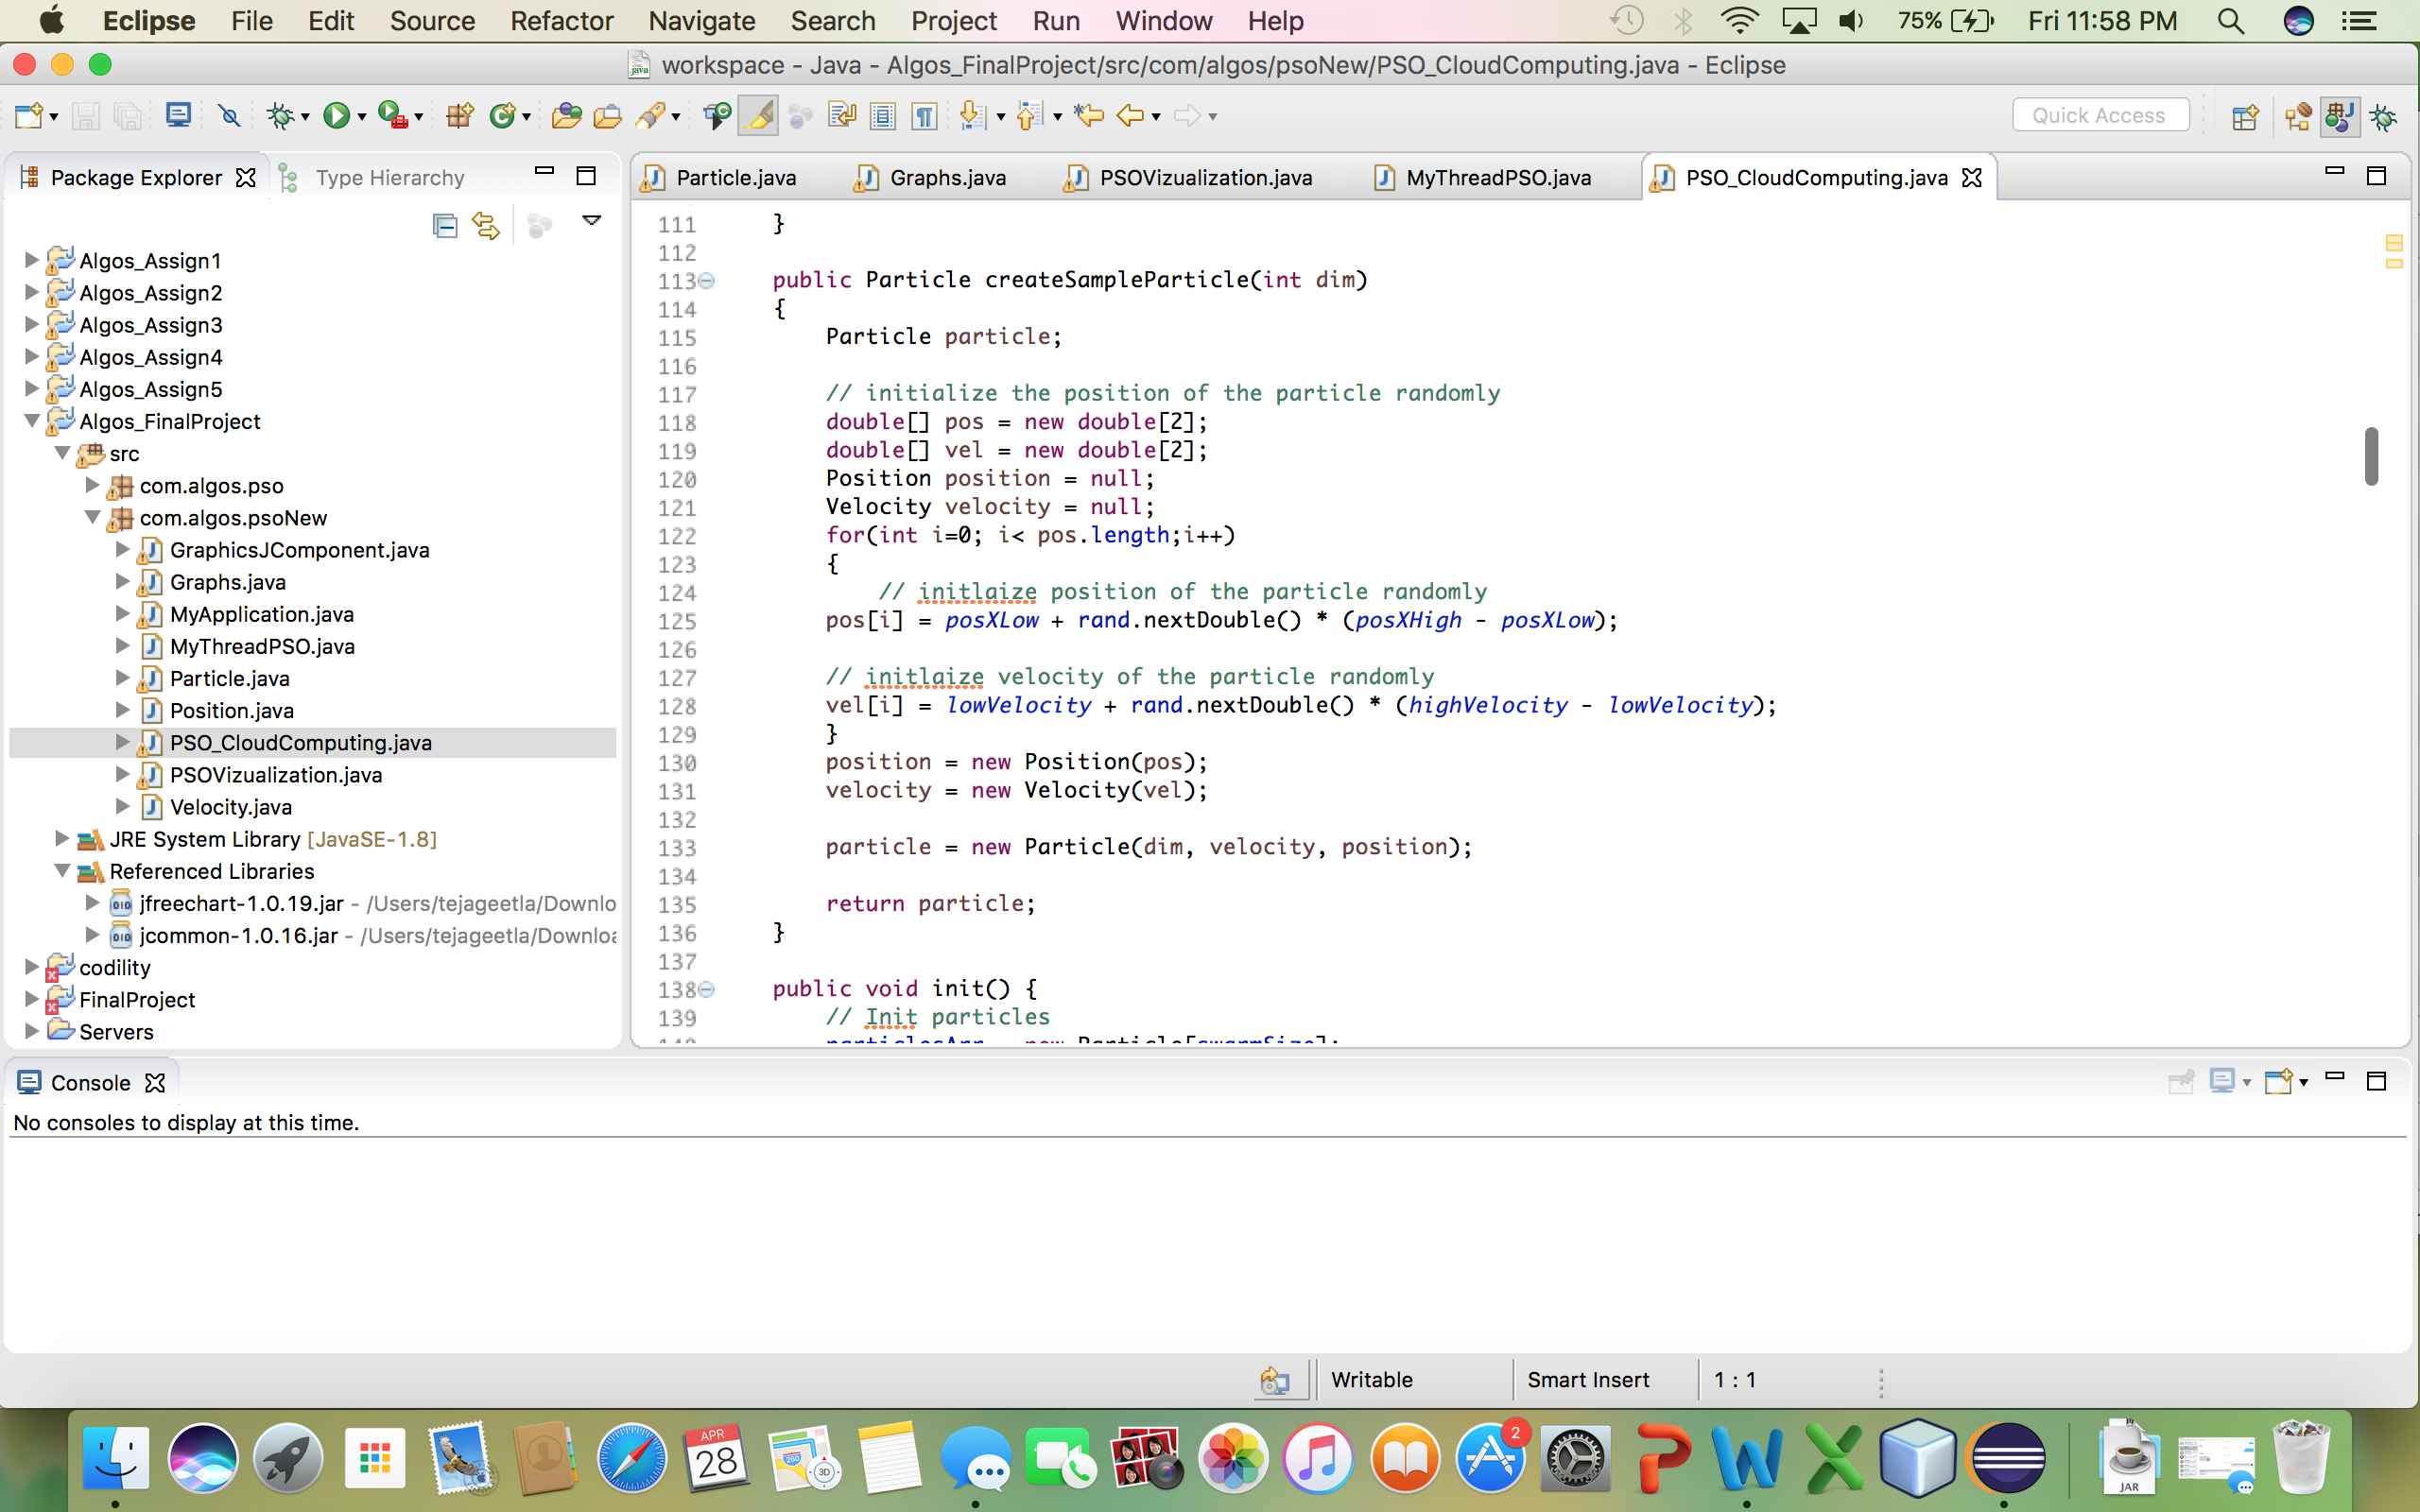

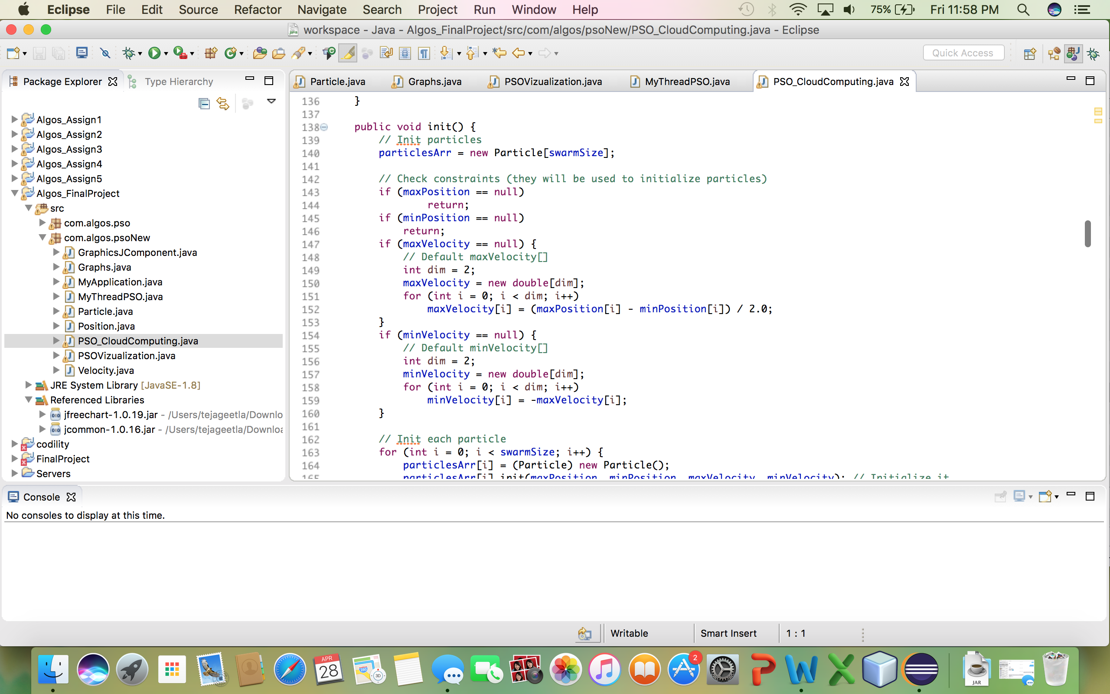

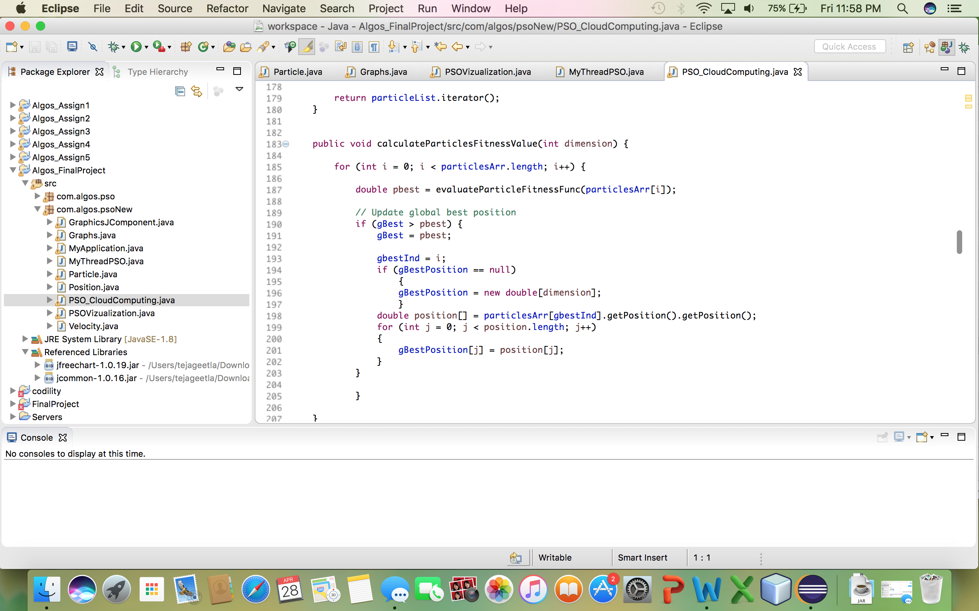

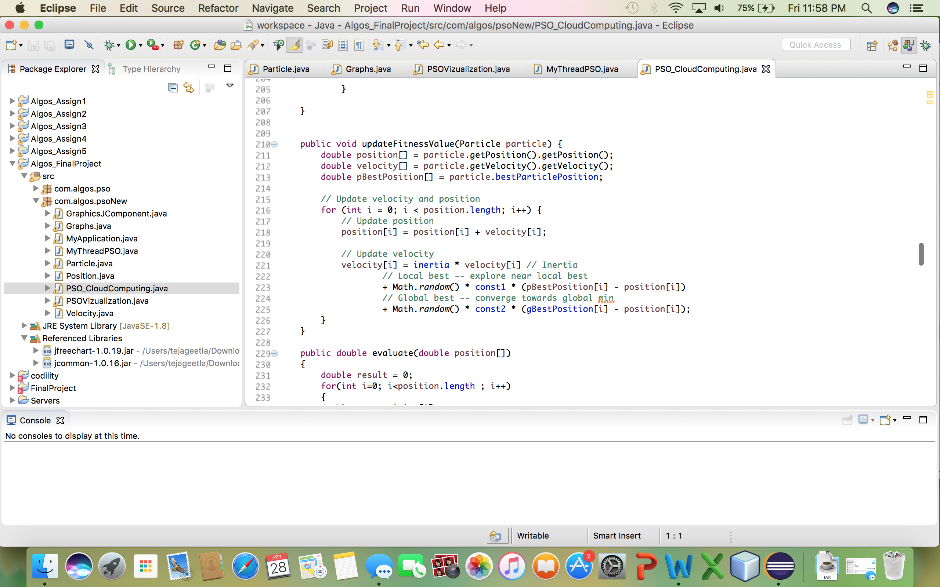

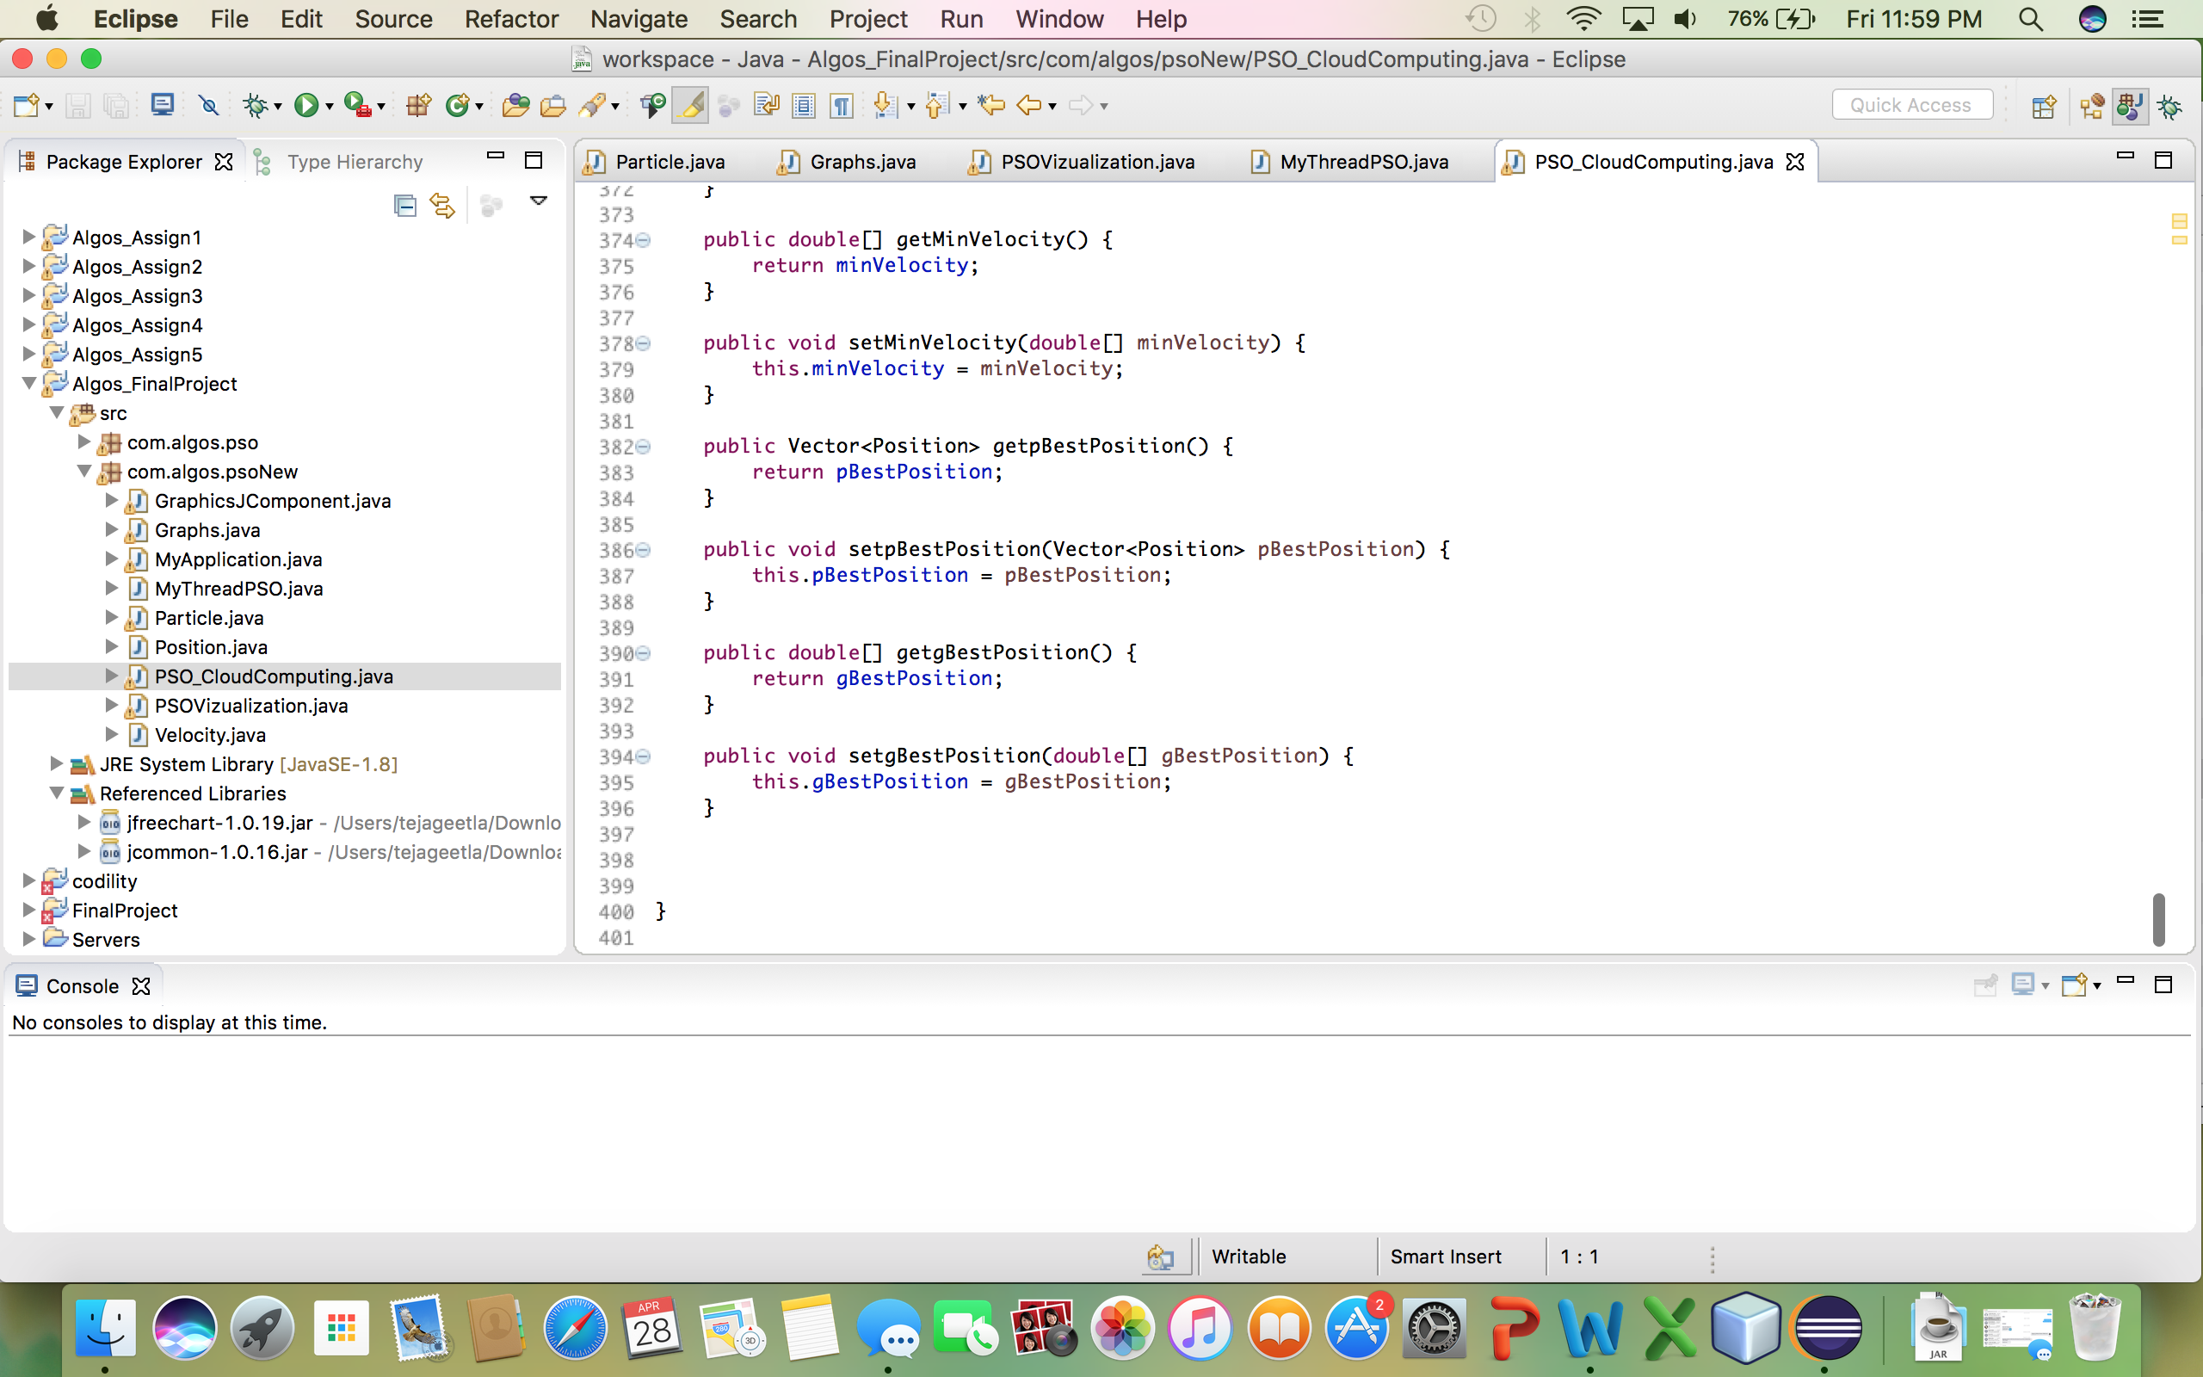

Reference:

<https://www.hindawi.com/journals/mpe/2015/931256/>

<http://files.matlabsite.com/docs/papers/sp/pso-paper-057.pdf>

<https://en.wikipedia.org/wiki/Particle_swarm_optimization>

<http://ieeexplore.ieee.org/abstract/document/5474725/?reload=true>